

Functional System DOCUMENT FOr MERCHANT DASHBOARD

OCT 2024

|  |  |
| --- | --- |
| **Document Control Sheet** | |
| **Current Version** | 1.0 |
| **Project Code** | CE_SBI_04_08_2024 |
| **Project Name** | SBI ePay Implementation |
| **Document Type** | ePay Merchant Dashboard |
| **Author** | Shreyash Bamane |
| **Reviewed By** | Karan Thakkar |
| **Frequency of Document Review** | Next Revision of Standard Documents |
| **Document Creation Date** | 11-10-2024 |
| **Last Updated Date** | 11-10-2024 |

|  |  |  |  |
| --- | --- | --- | --- |
| **Revision History** | | | |
| **Version** | **Date** | **Name** | **Comments** |
| 1.0 | 11-10-2024 | Shreyash B | Draft Version |

# Contents

Contents 2

Document Purpose 4

Scope 4

Functional Flow 5

1. Login 5

2. Merchant Panel- 14

2.1 Header bar 15

2.2 Information Section 18

2.3 Menu Bar 18

2.3.1 Dashboard 19

2.3.1.1 Merchant Business Profile Card 19

2.3.1.2 Transaction limit 20

2.3.1.3 Transactions Trend 22

2.3.1.4 Transactions Summary 24

2.3.1.5 Recent Transaction 24

2.3.1.6 Active Refund Details 26

2.3.1.7 Available Amount for refund 26

2.3.1.8 Chargeback details 27

2.3.2 Reports 27

2.3.2.1 Reports Download 28

2.3.2.2 Schedule Reports 30

2.3.2.3 Standard Reports and formats- 32

A. Order Reports 32

B. Settlements Reports 33

C. Transactions Report 33

D. Refunds Report 33

E. Chargeback Report 34

2.3.3 Transaction & Refunds 34

2.3.3.1 Recent Transactions 34

2.3.3.2 Orders & transactions 36

2.3.3.3 Bulk Refund 39

2.3.3.4 Refund Status 43

2.3.4 Invoices 44

A. Transaction Fee invoices 44

B. GST invoices 44

2.3.5 User Management 45

2.3.5.1 Roles Hierarchy 46

2.3.5.2 Details 46

2.3.5.3 User management View 48

A. Profile Tab 48

B. Manage Users 50

C. Activate Users 52

D. MID mapping 54

E. Tool mapping 55

2.3.6 Account & Settings 57

2.3.6.1 Transaction Limit 59

2.3.6.2 Bank Account 60

2.3.6.3 Keys 63

2.3.6.4 Payment Page Theme 65

2.3.7 Help & Support 67

2.4 Footer Bar 68

# Document Purpose

This document outlines the features to be covered in Merchant Dashboard that will enable merchants to have a holistic view of engagement with SBIePay.

# Scope

The scope of document includes modules of merchant panel such as merchant dashboard, user management, reports, accounts and settings.

# Functional Flow

# 1. Login

- Login page of the merchant panel will have SBIePay logo and a login box below it to enter login credentials (Mobile Number/Email ID/User ID) and Password, and a ‘Continue’ button which will be disabled until both the fields are filled, as per screenshot below.

* User will enter valid mobile number/ Email ID/ unique User ID and will move to password field.
* As soon as the cursor moves to password field, entered Mobile Number/Email ID/User ID will be validated by system in the background, and the same will be indicated to the user. (Green tick in case of valid ID and red ‘!’ symbol in case of invalid ID)
* User will then enter their password (default password provided by SBIePay onboarding team during first login), or password set by new user through link received on their registered email ID).
* Mandatory captcha also must be entered.
* User will then click on ‘Continue’ button.
* After ‘Continue’ button is clicked, system will validate the password and captcha. If it is incorrect, the same will be notified with an alert message as per screenshot below.

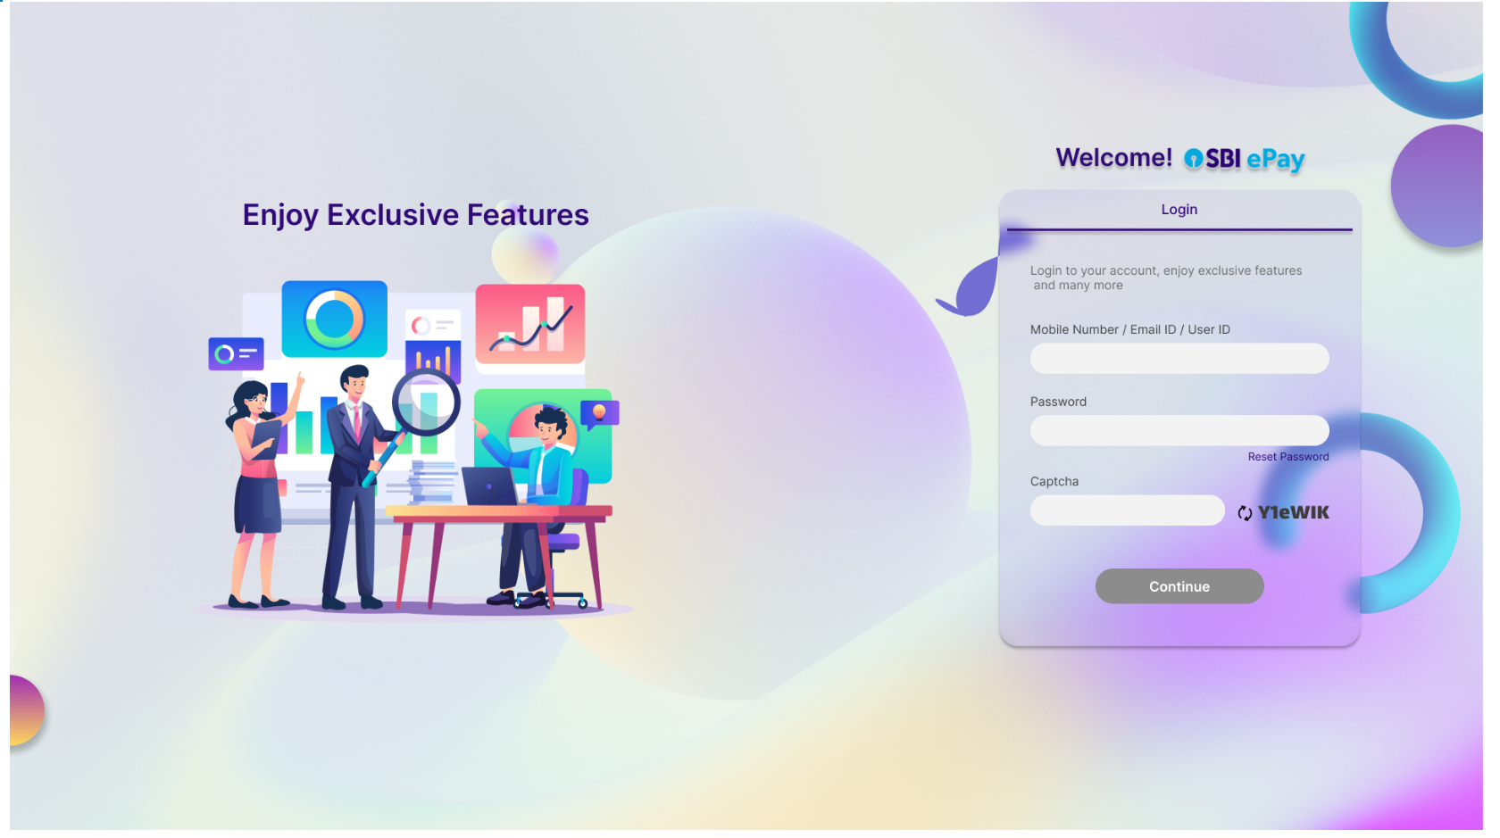

* If user has forgot password, they can click on ‘Reset Password’, and following screen will appear.

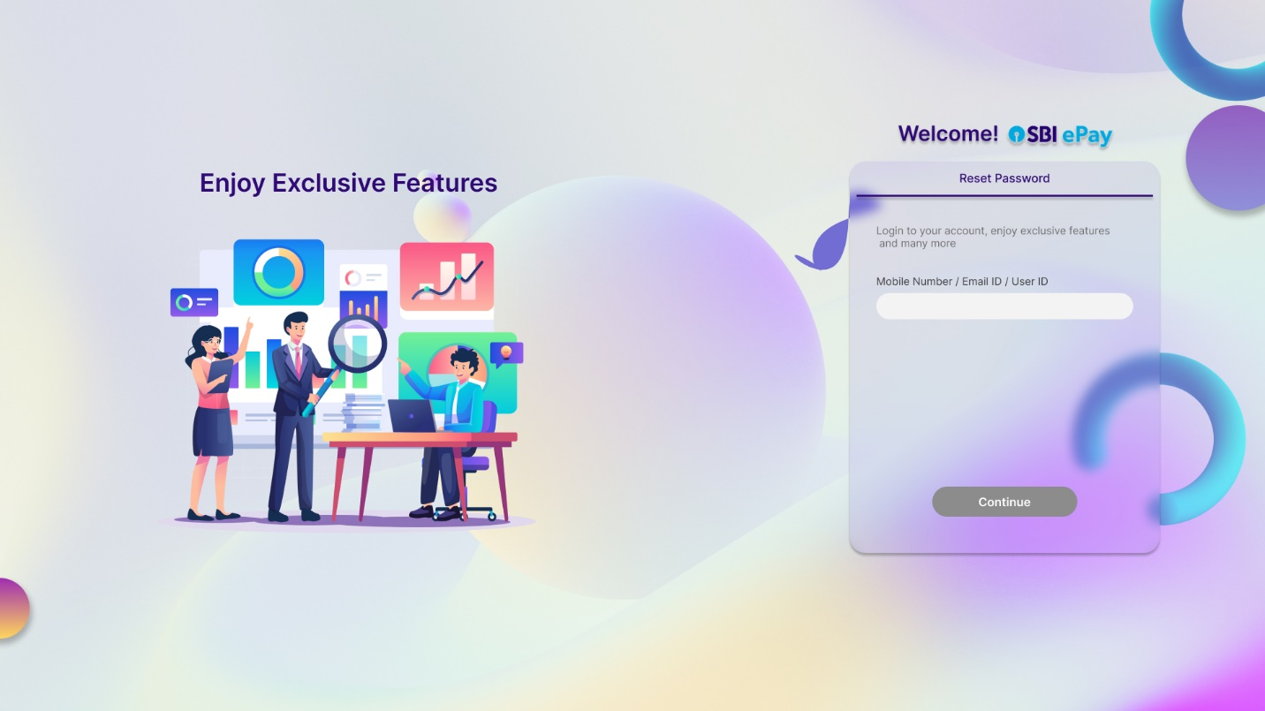

* User will enter correct ID and will click on ‘Continue’ to receive an OTP that needs to be entered in the next screen along with captcha as per screenshot below-

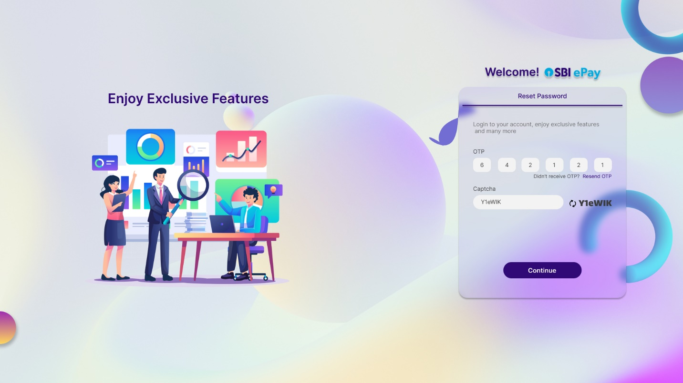

* Clicking on ‘Continue’ button will take user to the screen where they can enter new password (twice).

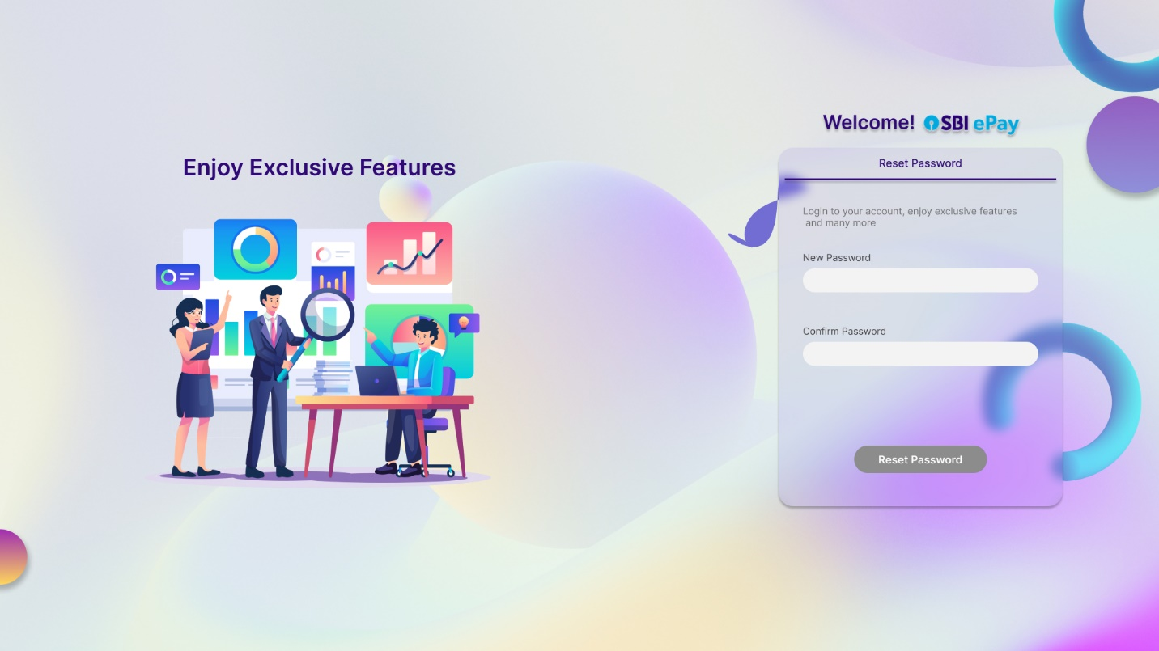

* If re-entered password does not match with the new password, user will be shown following error screen-

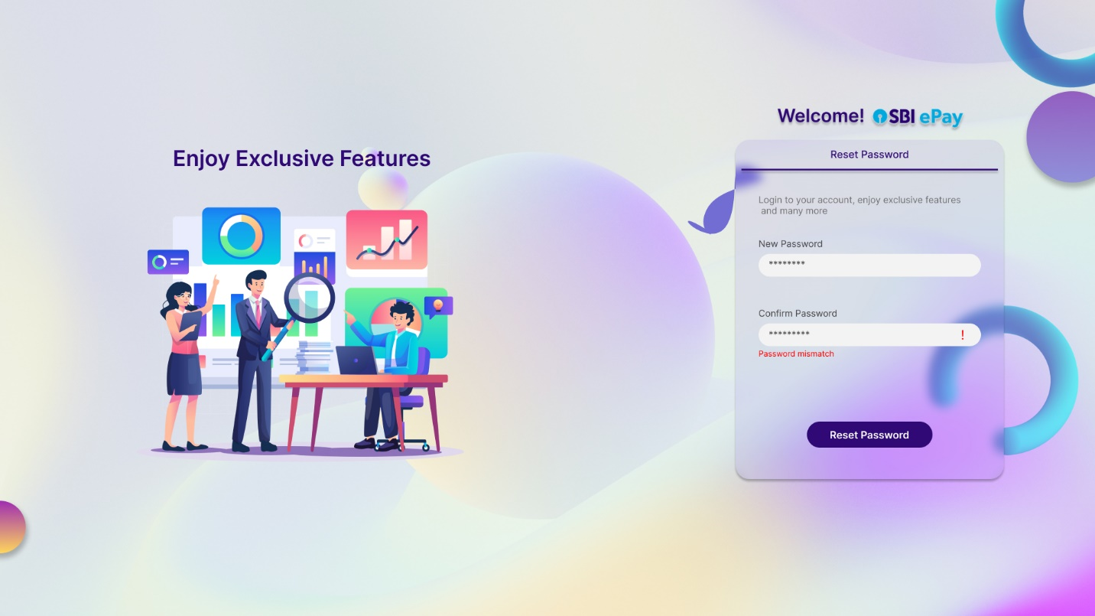

* If password matches, user will see following screen.

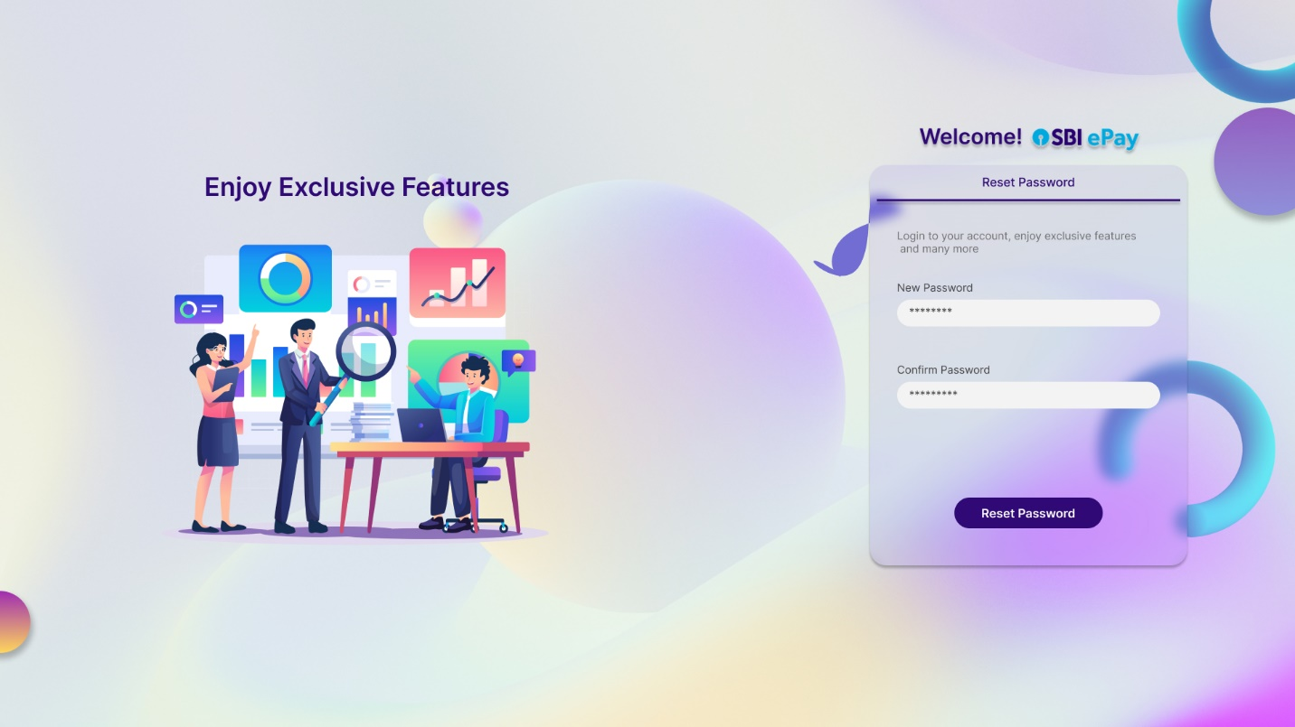

* User will then click on ‘Reset password’ to see following screen.

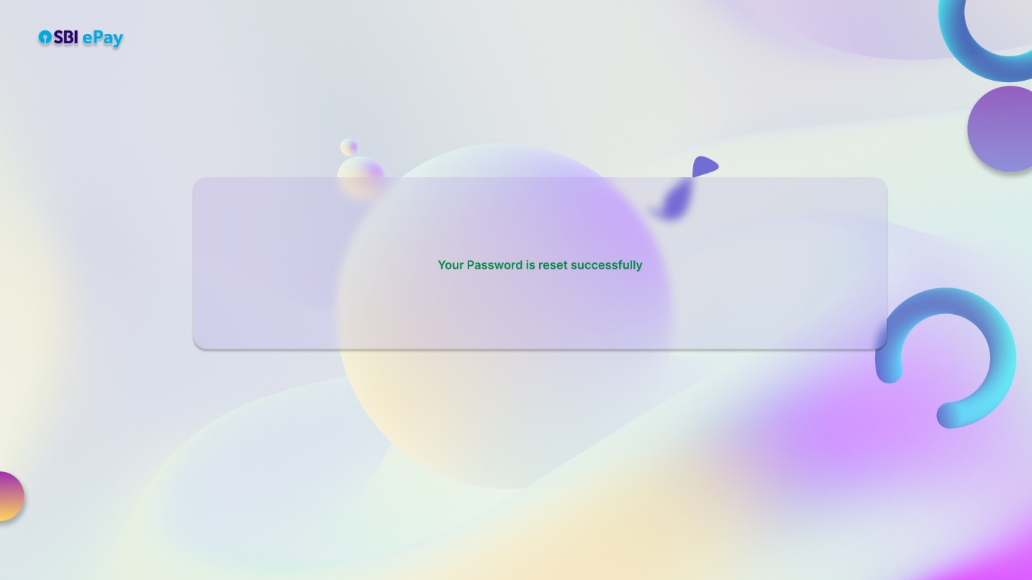

* Above screen will be visible to user for a few seconds, and then they will be redirected to login page again.
* In the main login page, upon entering correct mobile number/Email ID/user ID, password and captcha, user will see below screen.

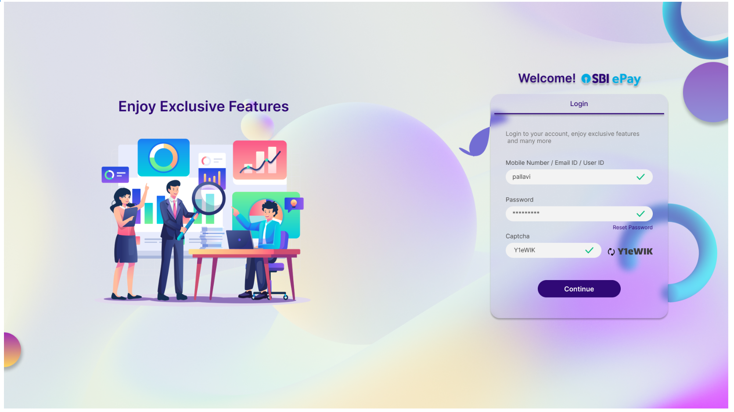

* By clicking on ‘Continue’ button, an OTP will be sent on user’s email id and/or mobile number and they will be taken to the OTP screen as per screenshots below-

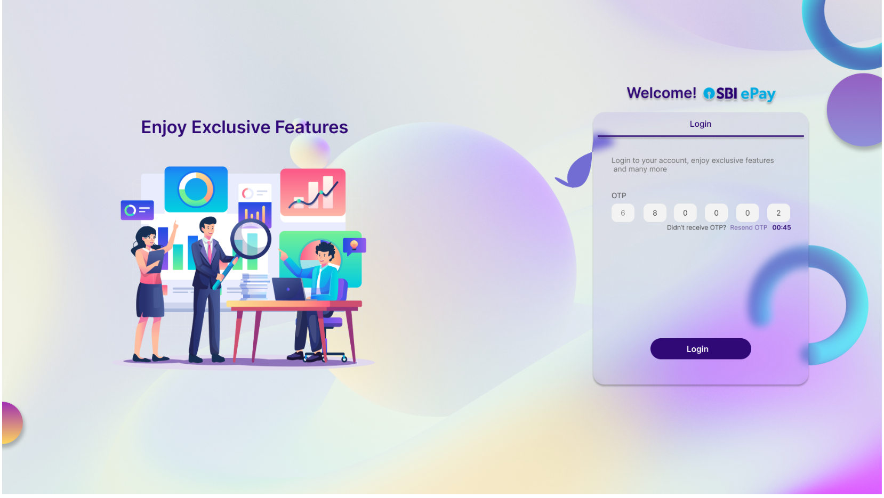

* As seen in screenshot above, soon as OTP is triggered, a timer of 60 seconds will appear with a disabled ‘Resend OTP’ button.
* In case the user does not receive OTP and 60 seconds of timer has been lapsed, the ‘Resend OTP’ button will be enabled and user will click on the same to attempt receiving the OTP again.

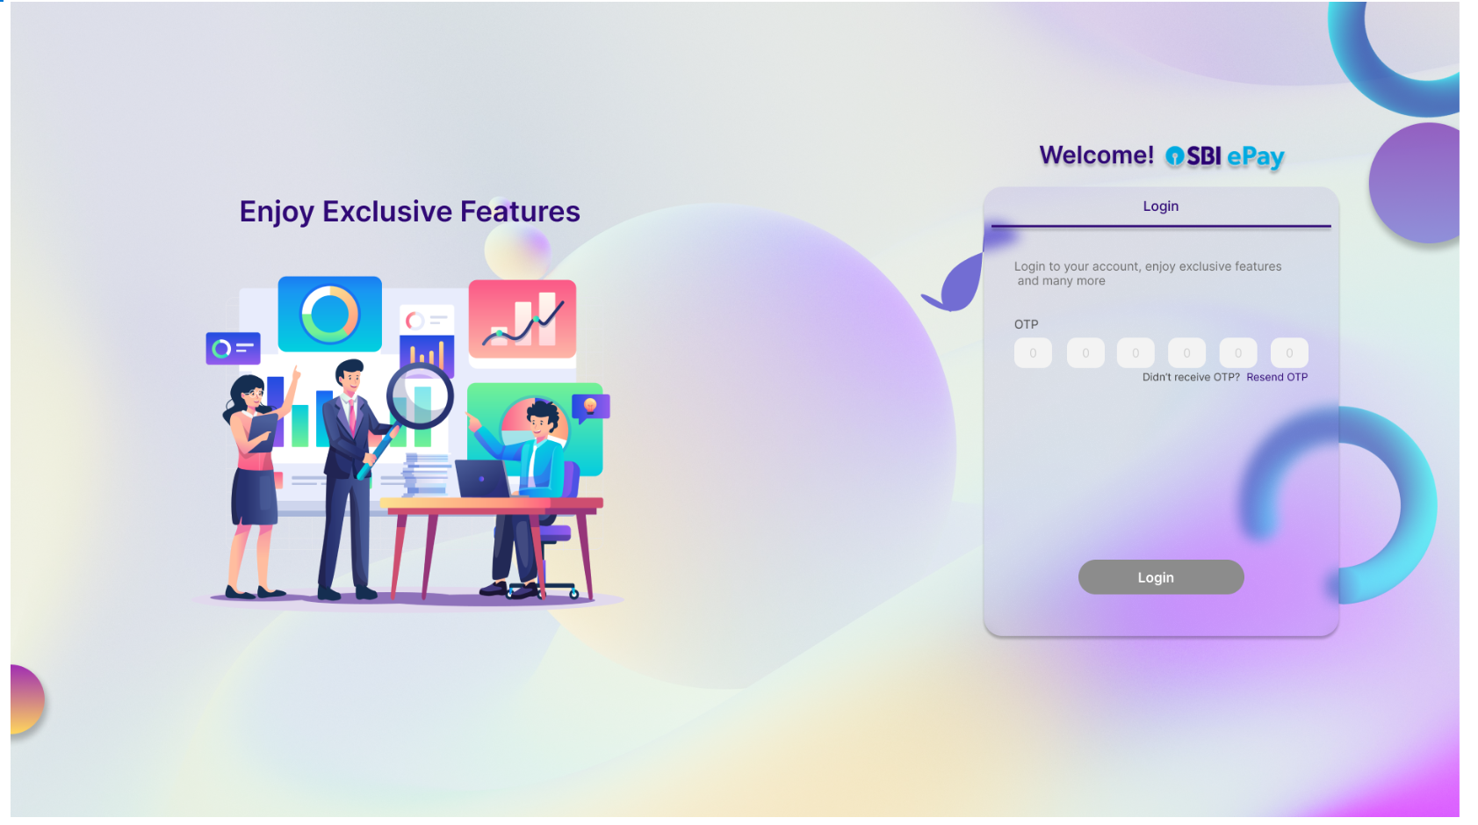

* If the password is expired, user will be alerted about the same and will be redirected to a screen where merchant can set a new password.

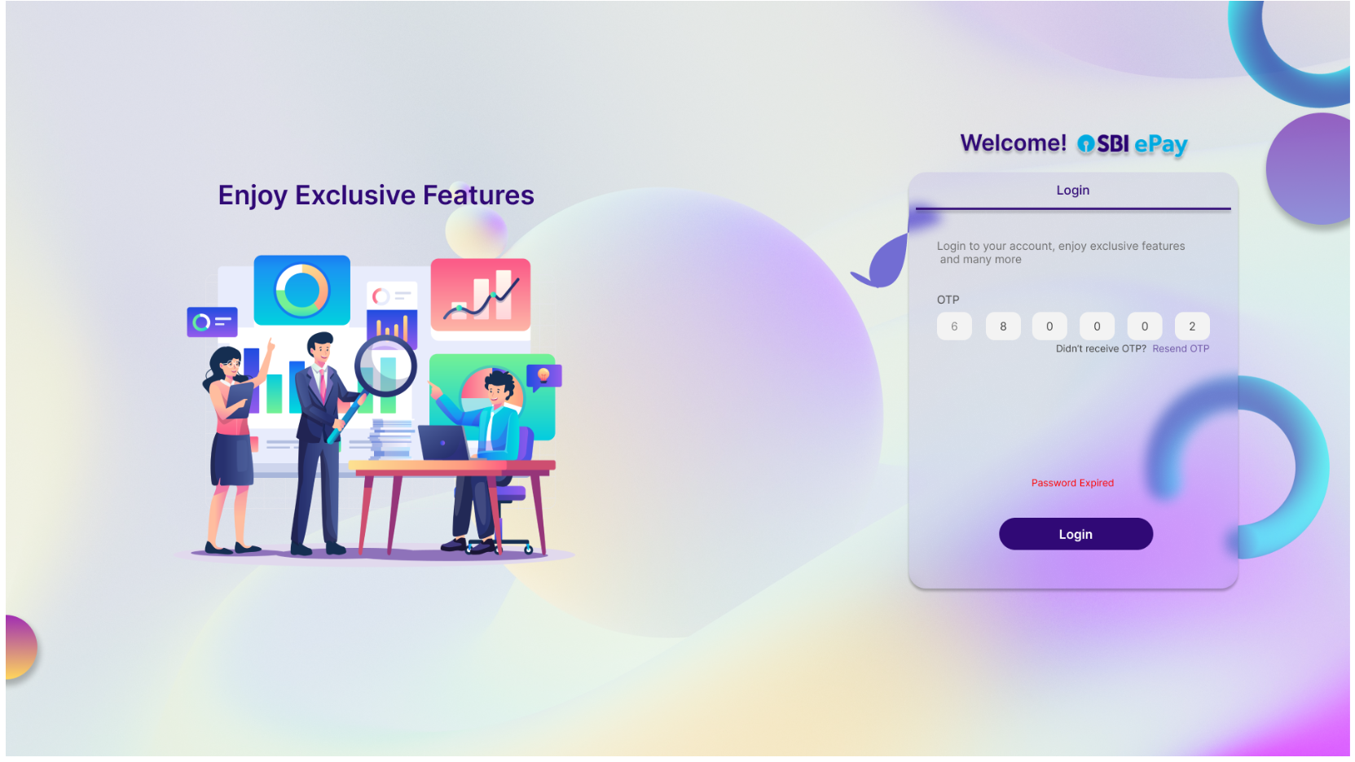

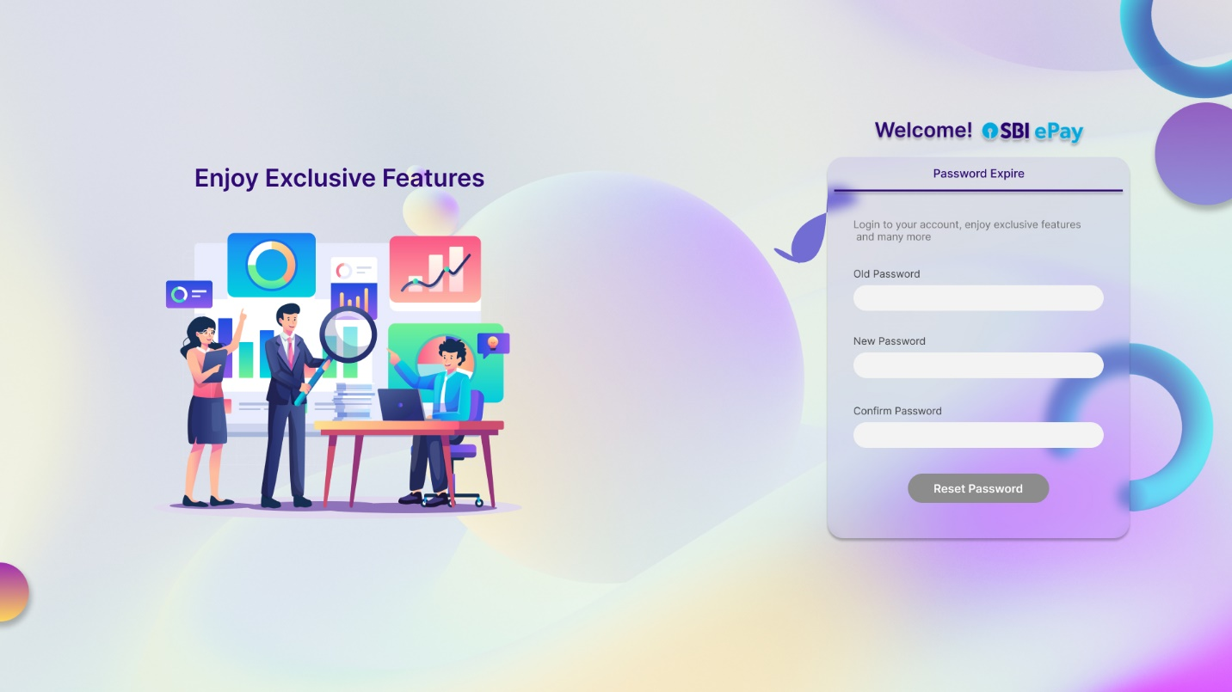

* In the screen above, the user has to enter the old (expired) password first and then the new password (twice).
* If the new password does not match with confirm password, following alert will be shown to user.

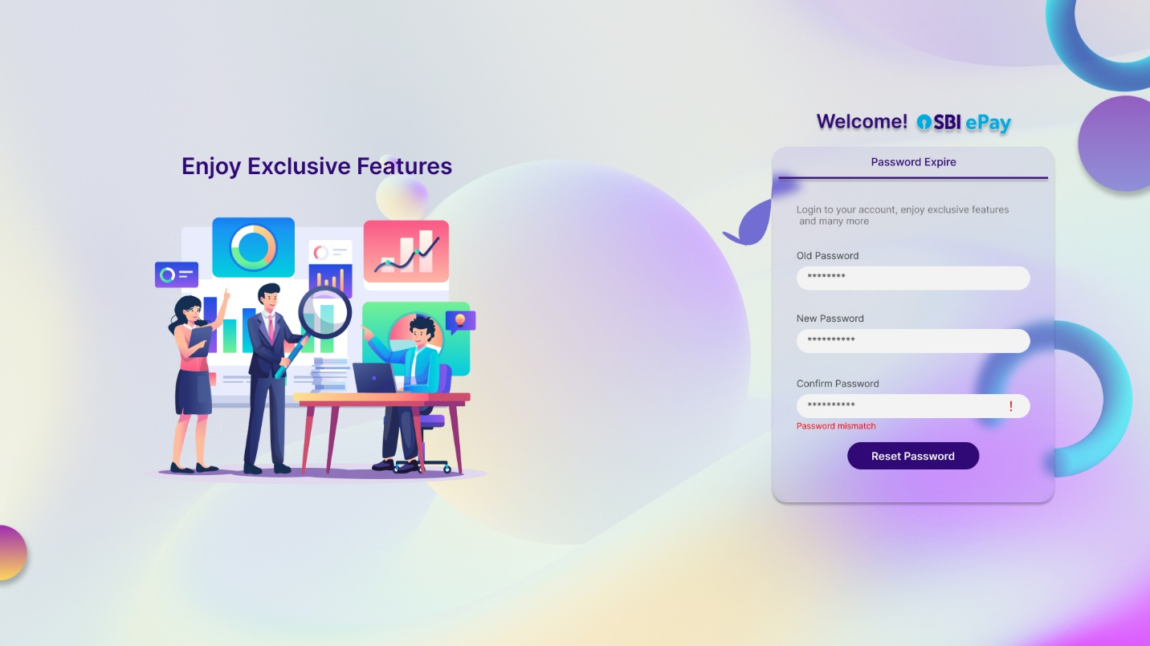

* If the ‘confirm password’ matches with ‘new password’, no alert will be shown.

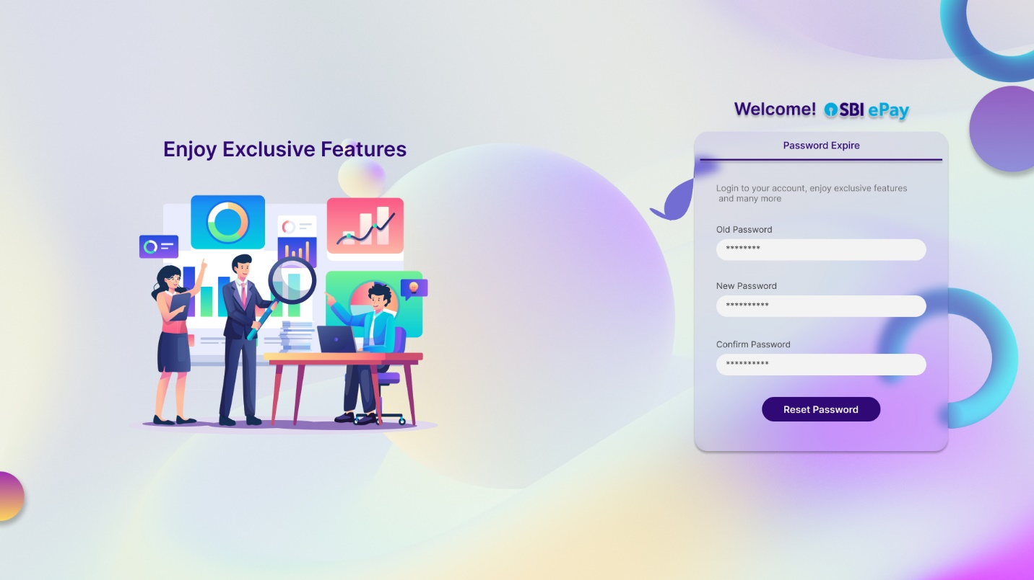

* After clicking on ‘Reset Password’ button with valid old and new password, user will see following screen.



* Above screen will be visible to user for a few seconds, and then they will be redirected to login page again.

# 2. Merchant Panel-

After a successful login on merchant panel, user will be landed to following dashboard screen (by default).

**Note**: Merchant panel will be responsive and accessible from both desktop and mobile.

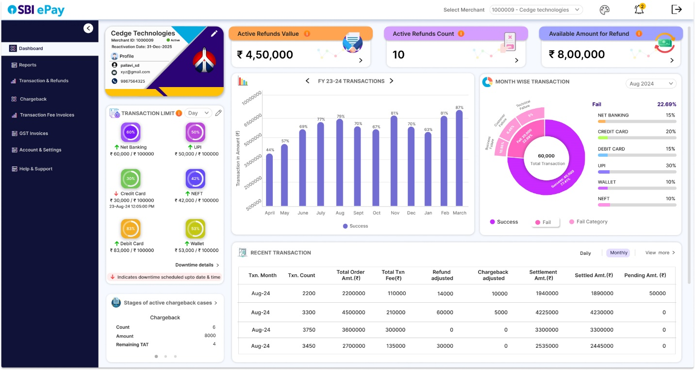

Merchant panel will have three sections, viz. Header bar, Menu Bar and information section as shown in screenshot above.

Content in information section will be updated as and when merchant switches from one section to another section in menu bar.

* + 1. Header bar

Merchant user will see following elements in header bar (from left to right)



* SBIePay logo- While accessing the merchant panel, clicking on SBI ePay logo will redirect user to Merchant dashboard menu.
* Theme button- Theme of the merchant panel (either dark theme or light theme) can be changed using this button. Once merchant will click this icon, a small section to appear using which user can select either the dark mode or light mode.
* Notification (bell) icon- Notification icon will have a count of unread notifications on corner of it so that user will click the same to open notification panel.

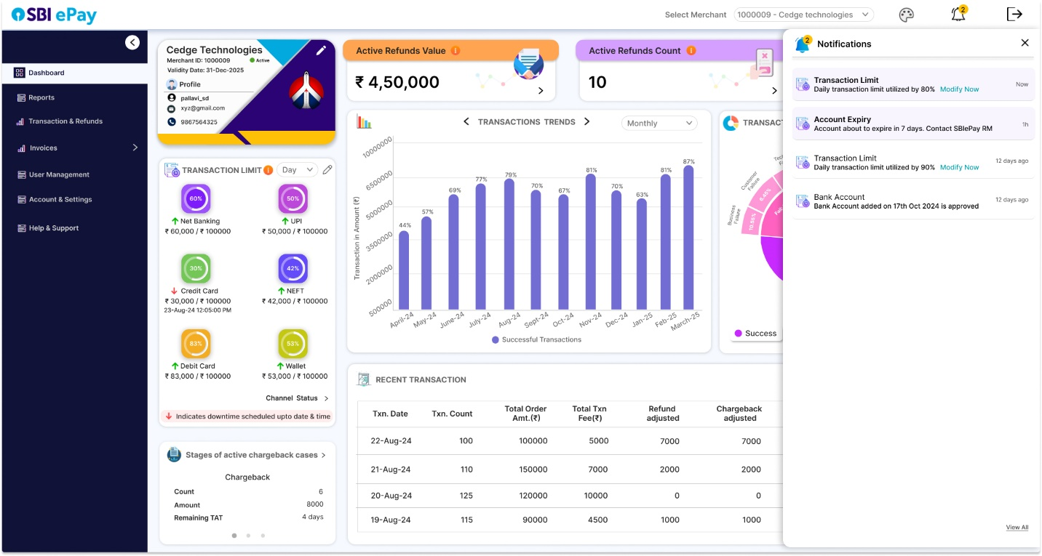

* The latest and unread notifications will be highlighted in notification panel as per above screenshot.

List of notifications-

1. <Daily/Weekly/Monthly/Quarterly/Half Yearly/Yearly> Transaction limit utilized by 80%. Modify Now.
2. <Daily/Weekly/Monthly/Quarterly/Half Yearly/Yearly> Transaction limit utilized by 100%. Modify Now.
3. Account about to expire in 30 days. Contact SBIePay RM.
4. Account about to expire in 15 days. Contact SBIePay RM.
5. Account about to expire in <7,6,5,4,3,2,1> days. Contact SBIePay RM.
6. Bank Account added on <date> is approved.
7. Bank Account modified on <date> is approved.
8. Transaction limit modified on <date> is approved.

User can click on ‘View All’ icon to open a detailed notification page.

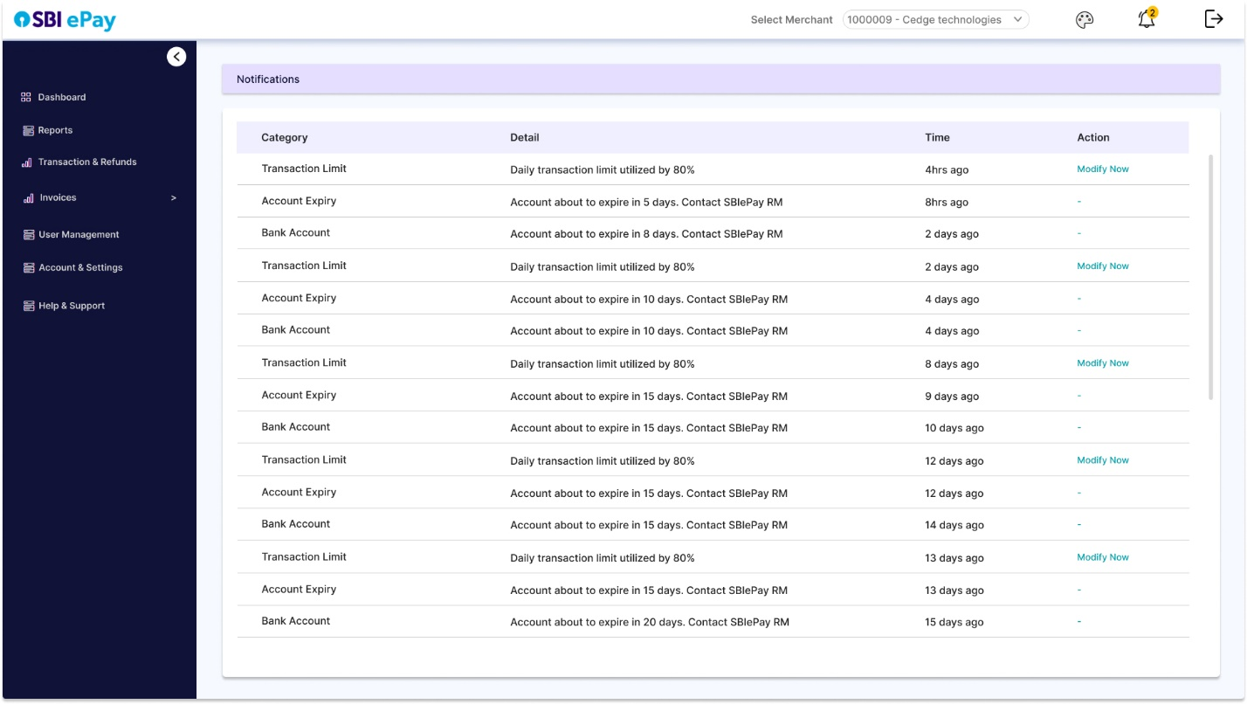

* MID dropdown-

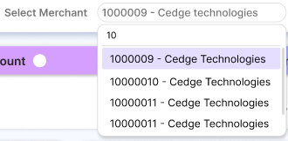

Users with Multiple MIDs access- Users who have rights to access multiple MIDs can click on this dropdown to display all the MIDs accessible to them.

Clicking on an MID will open dashboard view of that MID.

Users with Single MID access- Users who have access to single MID only can only view the single MID mapped to them in this field. They cannot select any other MID value in the dropdown.

* Logout button- Upon clicking this button, the user’s login session will end and the user will be logged out of the Merchant panel. User will have to enter login credentials again for accessing the merchant panel.

**Note:** Header bar will be fixed on top on all the pages and sections of merchant panel.

2.2 Information Section

Information section of merchant dashboard will be updated as and when merchant navigates from one menu to another menu of Menu bar.

2.3 Menu Bar

Menu Bar of merchant panel can be collapsed or expanded by a click. It should also be capable of enlisting sub-menus under a main menu. Proposed menu bar has following options:

* + 1. Dashboard

Merchant dashboard menu consists of sections such as Merchant profile card, Transaction limit section, Recent Transaction, Active Refunds value, Active refunds count and amount available for refund.

### Merchant Business Profile Card

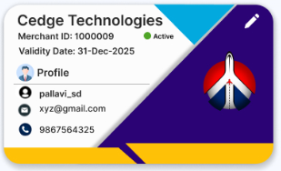

* Details such as Merchant Name (limited characters), merchant ID, Validity Date, username, e-mail ID and contact number of merchant profile will be displayed in a card layout.
* This profile card will also display the status of merchant, i.e. if the merchant is active or inactive.
* User will click on edit icon on top right of the card to get redirected to ‘Account & Setting->Profile’ tab, where user can edit their profile details such as e-mail ID, mobile number, name
* Font color of validity date will change to orange when less than 1 month is remaining for validity date. The same will change to red when 1 week is remaining.
* User will be notified in notification button and in a pop-up about the approaching validity date.
* These notifications and popups will be sent 1 month and 15 days before validity date, and will be notified every day when 1 week is remaining for validity date.

Sample notification and popup message-

“Account about to expire in <1 month/15 days/1 week>. Contact SBIePay RM.”

### Transaction limit

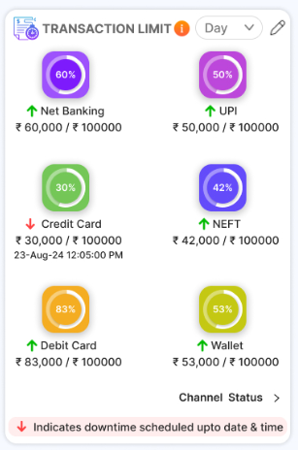

* User can check their real time pay-mode wise transaction limit exhausted against the actual set limit in transaction limit section, both in percentage and amount form.
* Pay-mode wise exhausted limit will be mentioned below the limit bar for every applicable pay-mode.
* User can view this data for frequencies such as ‘daily, weekly, monthly, quarterly, half-yearly and yearly’ by clicking on the dropdown on top right of this section.
* By clicking on edit button located on top right of this section, user will be redirected to ‘Account & Setting’ menu where they can place a request to change their transaction limit for any frequency. (Later to be approved by SBIePay admins.
* This request will then be processed by business RM from admin panel.
* User can also see the downtime for any pay mode in this section.
* Green upward arrow in front of a pay mode will indicate active service and red downward arrow will indicate downtime.
* If a service is in downtime till a predefined date and time, the same will be indicated in front of the name of the service.
* User will click on ‘Downtime details’ option for a detailed status window mentioning the status of each service under a pay mode, e.g. the header section of this window will have a refresh button and a close button on top. Upon clicking the refresh button, the latest health status of services will be updated. Clicking on close button will close the window, as per screenshot below.

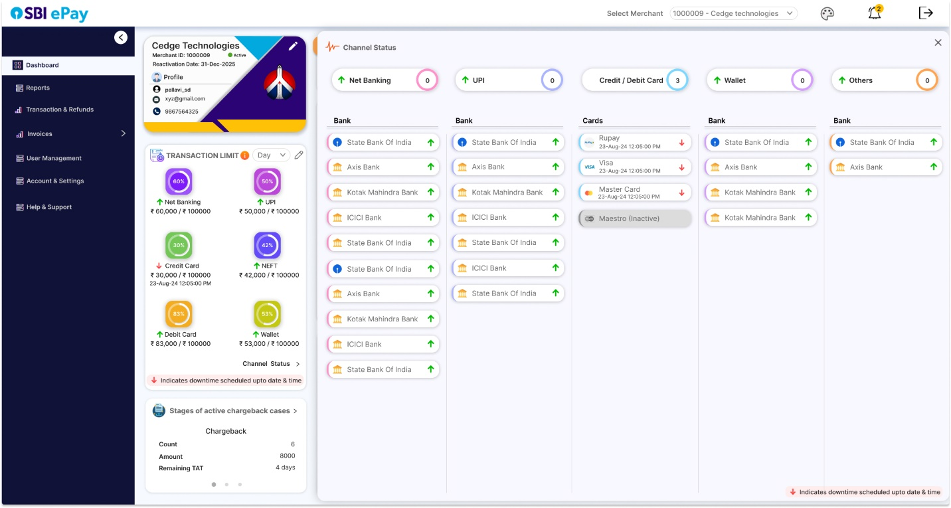

* In this window, each pay mode will be represented in columns.
* User will see pay mode names as column headers, and the individual channels will be enlisted under the each pay mode with their corresponding status arrow.
* The count of inactive services under any pay mode will be indicated in the column header for that pay mode.
* Any non-opted paymode will be grayed out and will be tagged as Inactive.

### Transactions Trend

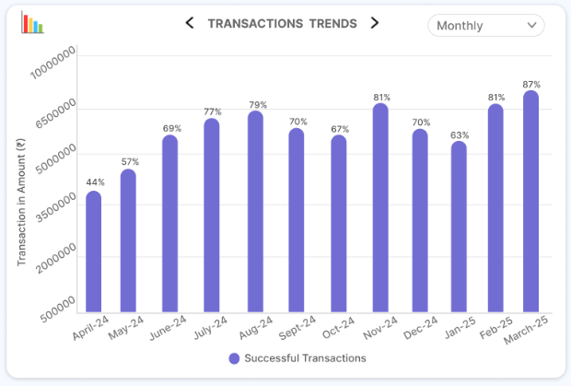

* By using this section, when user selects Monthly in dropdown, they will see month-wise successful transaction data for all transactions for complete financial year, (Months on X axis and successful transactions amount on Y axis)
* The scale of Y axis will be adjusted as per range of transactions of the particular merchant.
* Every month’s bar will have its success rate mentioned on it.
* When user hovers on any month’s bar, they will be able to see the transactions count as well.
* User will click on next/previous button to select the desired financial year for which the data needs to be displayed. (Current and previous year data to be displayed).
* Similarly, when user selects daily, they will see the same data but for latest 12 dates and upon clicking previous icon, data for previous 12 days.

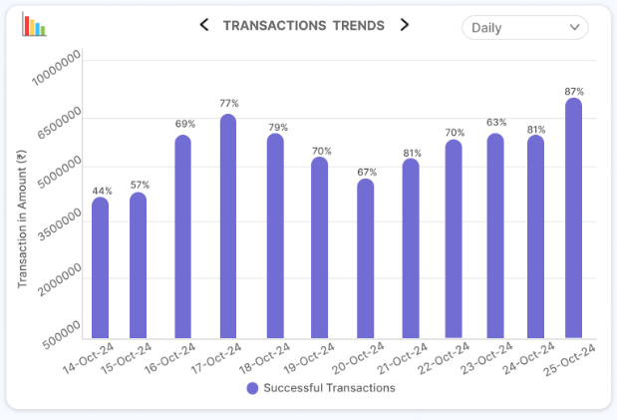

### Transactions Summary

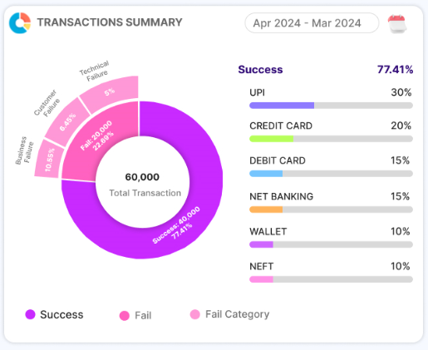

* In thi section, user will select any period and will be able to see a donut pie chart with breakup of successful and failed transactions for the selected period, along with the count of transactions.
* Failed transactions will further be classified into business failures, customer failures and technical failures.
* By clicking on any section of donut pie chart, table present on right side will display tabular representation of transaction percentage for all pay modes for the clicked transaction status. (sorted in descending order of percentage share).

### Recent Transaction

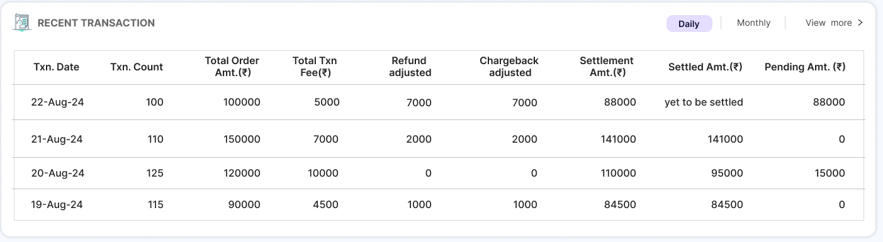

* Recent transactions will provide a gist of daily and monthly transactions amount, refund amount and pending amount for settlement.
* User can switch between ‘daily’ and ‘monthly’ buttons to display the data for the selected frequency.
* Data will be represented in columns such as Txn Date, Txn Count, Total Order Amount, Total Txn Fee, Refund Adjusted, Chargeback adjusted (only for merchants with refund against settlement), Settlement Amt, Settled Amount, and Pending Amount.

1. Txn Date- Date of transaction
2. Txn Count- Count of successful transactions
3. Total Order Amt- Total sum of successful transactions
4. Total Txn Fee- The total fee that needs to be deducted during settlement
5. Refund Adjusted- Refund Amount that needs to be deducted during settlement (only for merchants with refund against settlement opted)
6. Chargeback Adjusted- Chargeback Amount that needs to be deducted during settlement
7. Settlement Amount- Net Settlement amount, i.e. (c) – (d) - (e) – (f)
8. Settled Amount- The actual amount settled for the day
9. Pending Amount- Amount pending for settlement, i.e. (g) – (h)

* Clicking on ‘View More’ will redirect user to Transactions and Refunds->Recent Transaction, where user can view more transaction entries.
* As and when a partial and full amount is settled, columns like settled amount and pending amount will be updated in sync with progressive settlement as illustrated in table below, for a sample date of 22nd August 2024.

|  |  |  |  |  |  |  |  |  |  |
| --- | --- | --- | --- | --- | --- | --- | --- | --- | --- |
| Txn date | Txn count | total order Amt | total Txn fees | refund adj | CB  adj | settlement amount | settled amount | Pending amount | Day |
| 22-Aug-24 | 100 | 100000 | 5000 | 7000 | 5000 | 83000 | yet to be settled | 83000 | T |
| 22-Aug-24 | 100 | 100000 | 5000 | 7000 | 5000 | 83000 | 75000 | 8000 | T + 1 |
| 22-Aug-24 | 100 | 100000 | 5000 | 7000 | 5000 | 83000 | 79000 | 4000 | T + 2 |
| 22-Aug-24 | 100 | 100000 | 5000 | 7000 | 5000 | 83000 | 83000 | 0 | T + 3 |

* Data for previous days is displayed in “Newest to oldest” order.
* When merchant will click on ‘Monthly’ same details will be displayed as a sum total of all the days of the ongoing month.
* As and when new transactions take place, figures in ongoing month will keep on updating.
* Numbers for previous months will be displayed in newest to oldest order. (Only 4 entries visible).
* Upon clicking view more, user will be redirected to Transactions & Refunds-> Recent Transactions section, where more entries of recent transactions will be visible.

### Active Refund Details

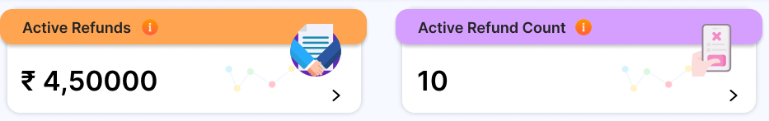

* On the top section of dashboard page, amount of active refunds and count of active refunds will be displayed.
* This amount and count will keep on updating in real time, i.e. it will increase when new refund are initiated, and will decrease when refunds are processed.
* Clicking on any of the section (refunds amount or refunds count) will redirect user to ‘Transactions & Settlement’ -> Refund Status tab.

### Available Amount for refund

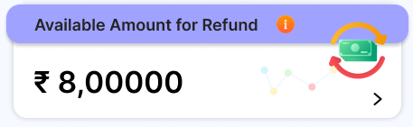

* This section will display the amount available for refund.
* Clicking on this section will redirect user to Transaction & Refunds-> Orders & Refund menu

### Chargeback details

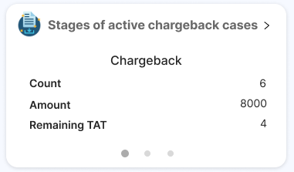

* User will be able to see count and amount of chargeback cases segregated as per their stages.
* User can click on gray dots to switch the stage, and display its count of cases, total amount (Rs.) and remaining TAT (number of days).
* If N number of cases are in a particular stage, then the least remaining TAT among those cases will be displayed in the dashboard for that stage.
* Clicking on the title will redirect user to existing chargeback module.
  + 1. Reports
* User will navigate to reports section to download or schedule reports related to orders, transactions, settlement etc.

### Reports Download

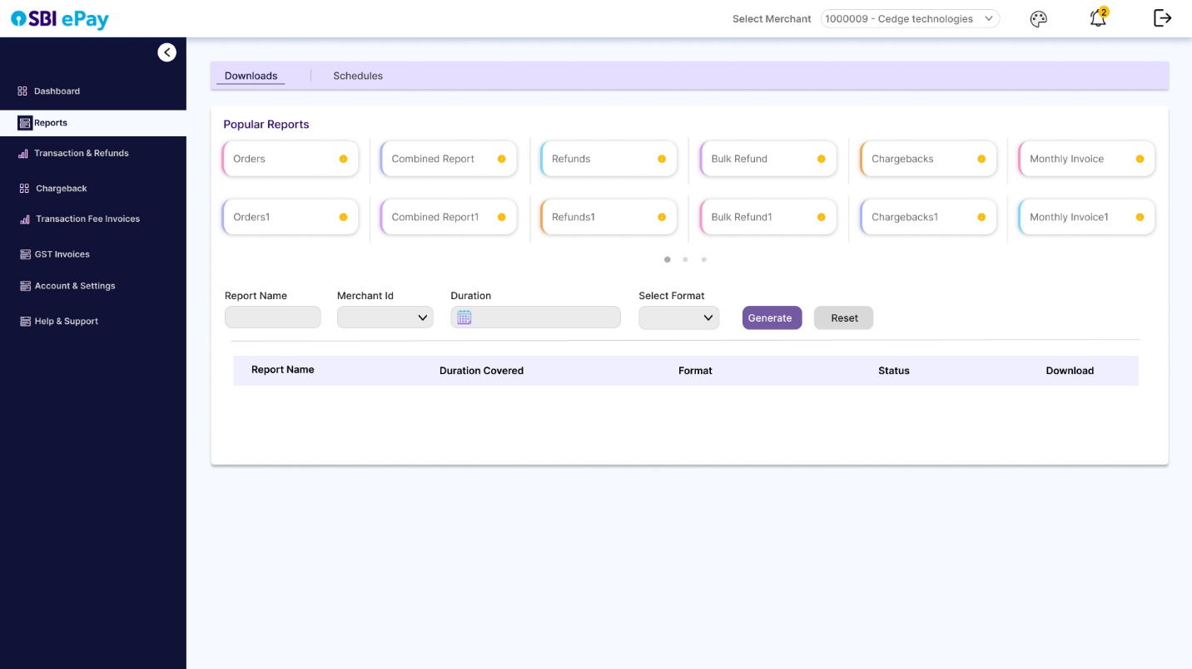

* In downloads tab of Reports section, user will be able to see tiles of most used reports and report parameters below that. No value will be selected by default when user lands on this tab after clicking on ‘Reports’. Only ‘Select’ text will be visible. User can select the tile of desired report.
* Alternatively, user can select/search report from the ‘Report name’ field present below the tiles, which will contain an exhaustive list of all the reports applicable to
* that merchant.
* If user has access to more than 1 MID, then user will see a drop down of Merchant ID selection. User can select one, more than one or all the MIDs mapped to them.
* d
* If user selects period as today, yesterday, last 7 days, last 30 days, last 90 days as period, duration will be auto-selected accordingly.
* If user selects custom, user has to select a valid duration from duration field (from date- to date), without which report will not be generated.
* User can select report format from format field.
* Clicking on generate button will add a new row at the top of the download report table with status ‘Generating’.

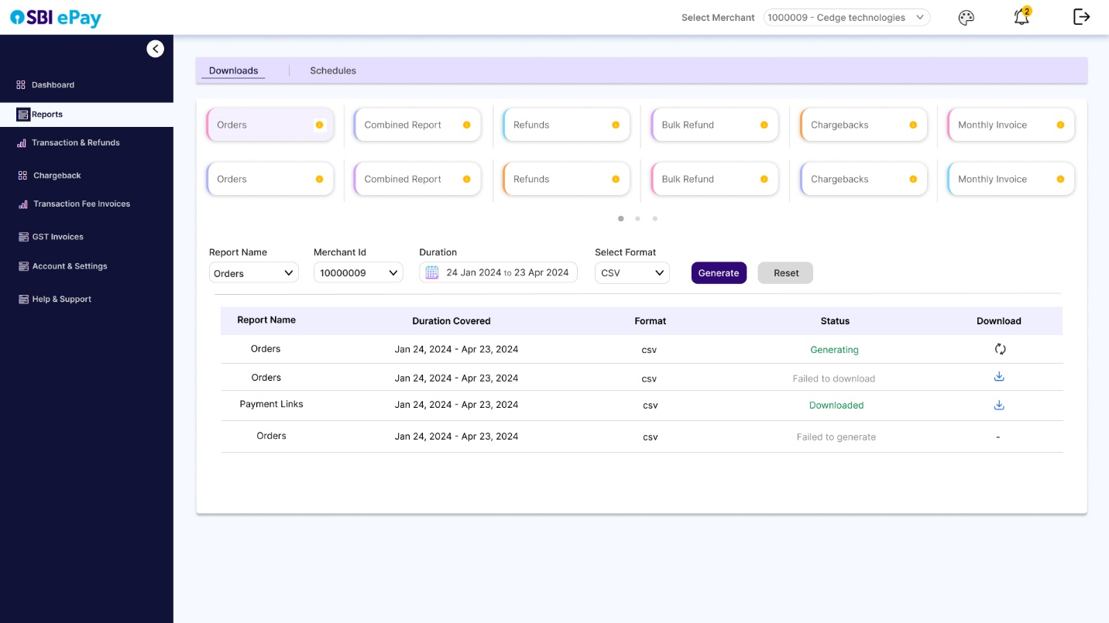

* Once the queued report is generated, the status in table will change to ‘Generated’ and download icon will appear in download column of the table. Clicking on this icon will initiate the download in user’s browser.
* Once download is completed, the status of report will change to ‘Downloaded’
* If download fails by any chance status will be ‘Failed to download’ and if report generation itself fails, status will be ‘Failed to generate’.
* User can refresh the page to update the latest status of report generation.
* Clicking on ‘Reset’ button will reset the selections done by user in report parameters and user will have to start afresh.

### Schedule Reports

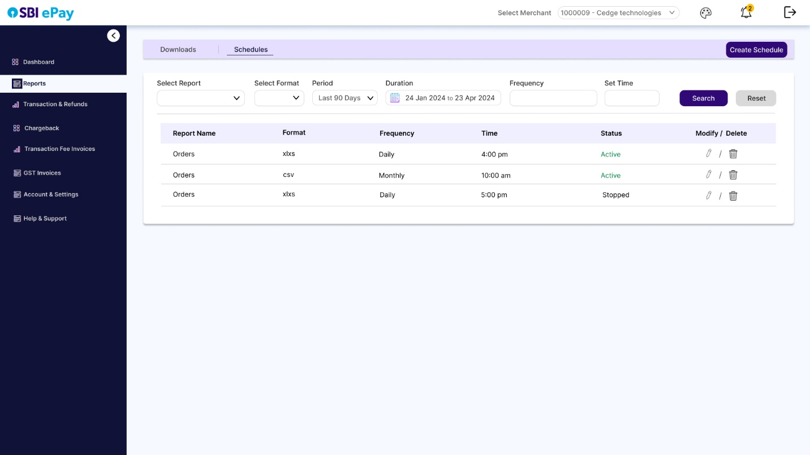

* Values will not be selected by default in schedule tab, ‘Select’ value will be visible by default.
* Using schedule tab, user can create a schedule and automate the report generation process, instead of downloading the report manually every time.
* User will click on ‘Create Schedule’ to open a drawer from right.

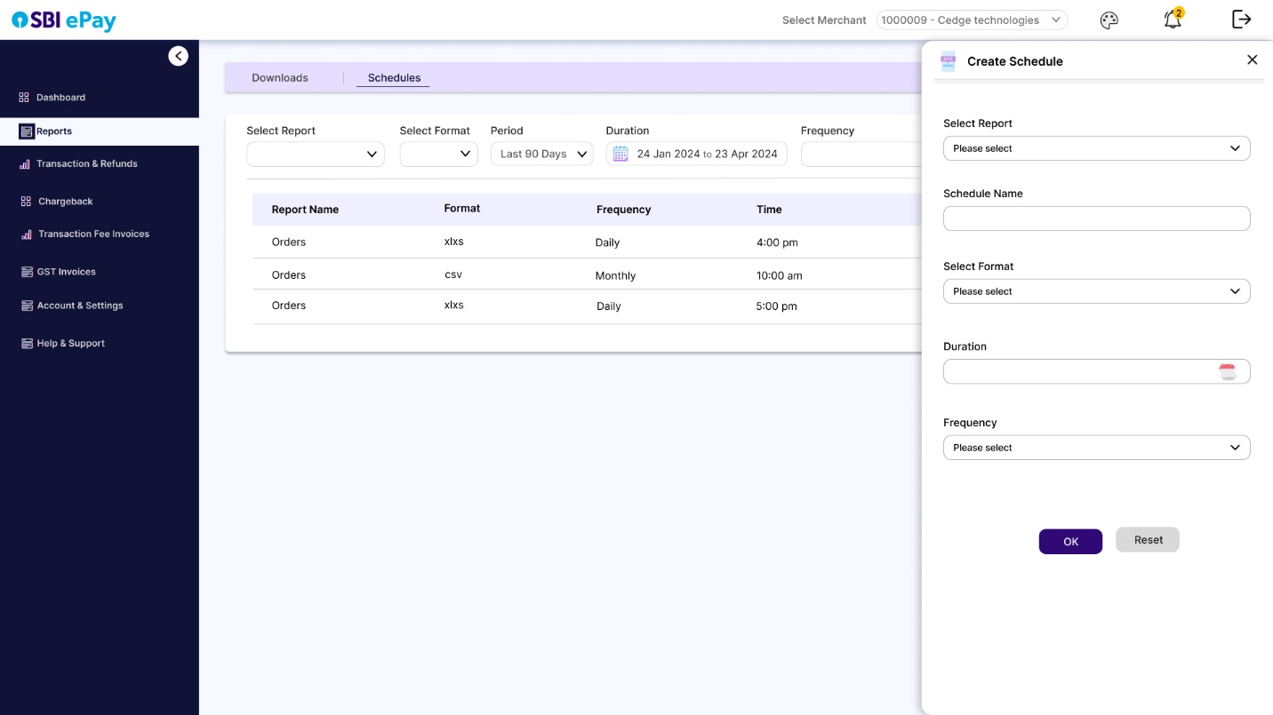

* Then they will enter the schedule name, select the report, its format, duration, period, frequency and time to create a report schedule.

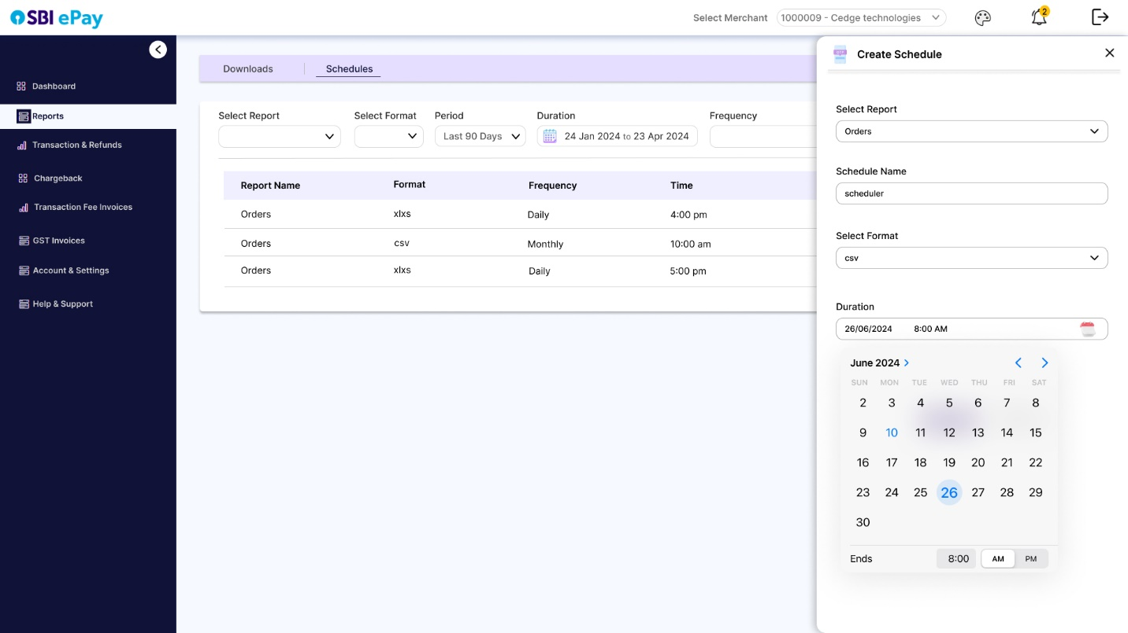

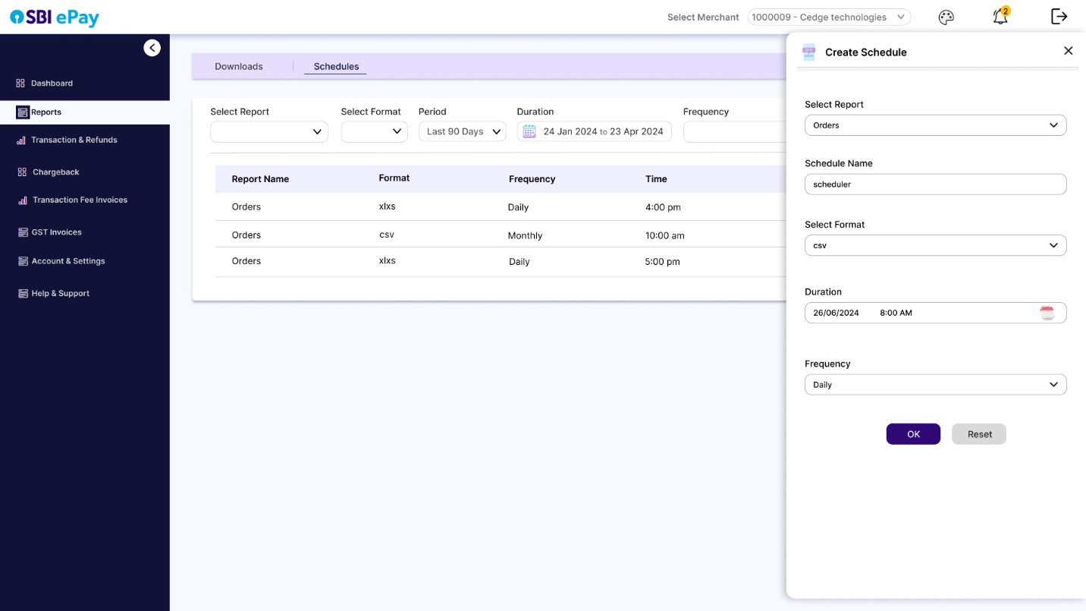

* All the created schedules will be visible in a tabular form with modify and delete action buttons.
* Created schedules can be filtered with the help of filter parameters.
* User can modify the report schedule, e.g changing its frequency, format by clicking on modify button.
* A schedule can be deleted using the delete icon.
* Once a schedule is live, report will be available to download in ‘download’ section as per set frequency and time.

### Standard Reports and formats-

* All the standard reports will be available in .csv, .xls, and .txt formats.

#### A. Order Reports

* Include information such as order ID, date, amount, customer id, order status, and attempts.
* Allow merchants to filter orders by date range.
* Merchant can select max date range up to 30 days from the selecting day. If max day is minimum from current day it will allow to choose till current day only.
* Format-

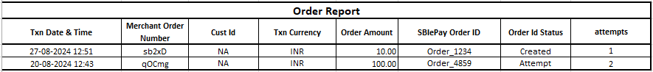

##### 

#### B. Settlements Reports

* Display detailed list of settled transactions, amounts, id, and settlement dates with transaction details.
* Allow access to historical settlement data with filtering options by date range.
* Merchant can select max date range till 30 days from the selecting day. If max day is minimum from current day it will allow to choose till current day only.
* Format-



#### C. Transactions Report

* Provide a comprehensive list of all transactions, including transaction ID, date, amount, and status (successful, pending, and failed).
* Drill down into specific transactions for more detailed information, including payment method and customer details.
* Allow access to transaction data with filtering options by date range.
* Merchant can select max date range till 30 days from the selecting day. If max day is minimum from current day it will allow to choose till current day only.
* Format-

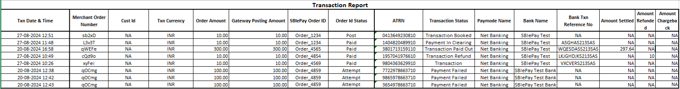

#### D. Refunds Report

* Show the status of all refunds, including processed, pending, and disputed refunds.
* Include refund type, refund ID, transaction ID & details, refund amount, date, and reason for the refund.
* Provide tools to track and manage refund disputes, with notes on resolution status.
* Allow access to refund transaction data with filtering options by date range.
* Merchant can select max date range till 30 days from the selecting day. If max day is minimum from current day it will allow to choose till current day only.
* Format-



#### E. Chargeback Report

* Track the status of each chargeback (e.g., initiated, under review, resolved) and include notes on resolution.
* Allow access to refund transaction data with filtering options by date range.
* Merchant can select max date range till 30 days from the selecting day. If max day is minimum from current day it will allow to choose till current day only.
* Format-



* + 1. Transaction & Refunds
* User will click on ‘Transaction & Refunds’ menu to refer to any information required related to orders, transactions and refunds, and to initiate refunds (bulk or single).
* This menu will also have ‘Recent Transactions’ tab where user will see summarized recent transactions for frequency like daily or monthly.
  + - 1. Recent Transactions

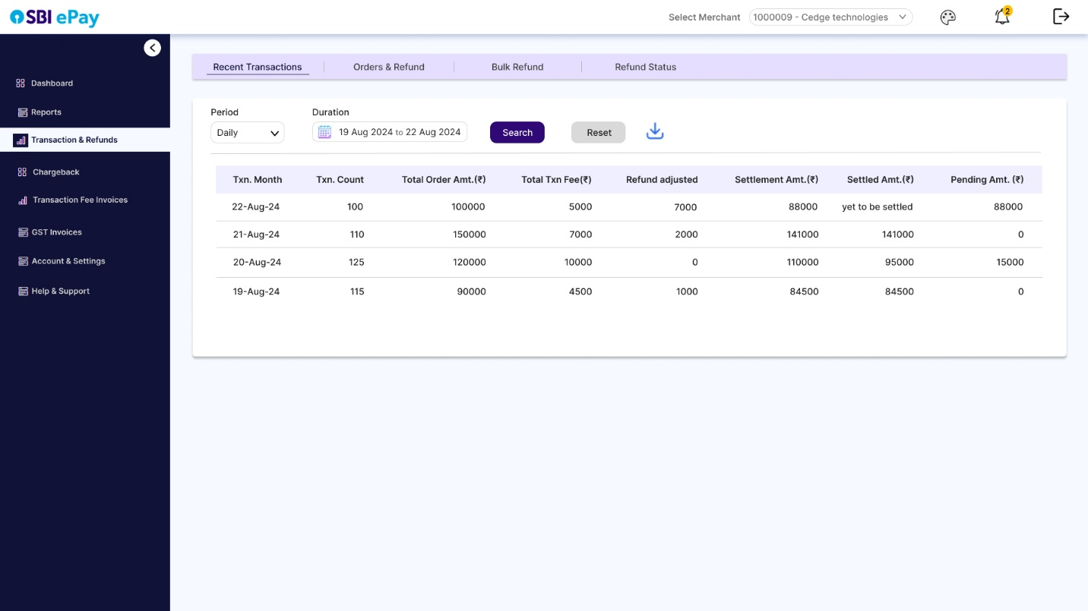

* This tab will function same as expanded view of ‘Recent Transaction’ section on dashboard screen, as explained in 2.3.2.6.
* On Dashboard, only limited entries will be displayed, whereas in ‘Transaction & Refunds’-> Recent transactions, multiple entries will be displayed.
* This view will additionally have a dropdown to select ‘Frequency’ wherein user can select either daily or monthly value. By default ‘daily’ value will be selected.

**Daily Frequency-**

* For daily frequency, user can select a period (today, yesterday, last 7 days, last 30 days, last 90 days and custom)
* By Default, ‘last 7 days’ value will be selected in ‘Period’ field and corresponding dates (from date- to date) will be visible in ‘Duration’ field.
* User can alter the filters as per their requirement and click on search button to display the records and click on download icon to download the csv/excel with displayed records.

**Monthly Frequency-**

* For monthly frequency, user can select a period (current month, last month, last 2 months, last 3 months, last 6 months and last year)
* By default, last ‘3 months’ will be selected in ‘Period’ field and corresponding months (from month- to month) will be visible in ‘Duration’ field.
* User can alter the filters as per their requirement and click on search button to display the records and click on download icon to download the csv/excel with displayed records.
* Following screen will be visible for monthly view.

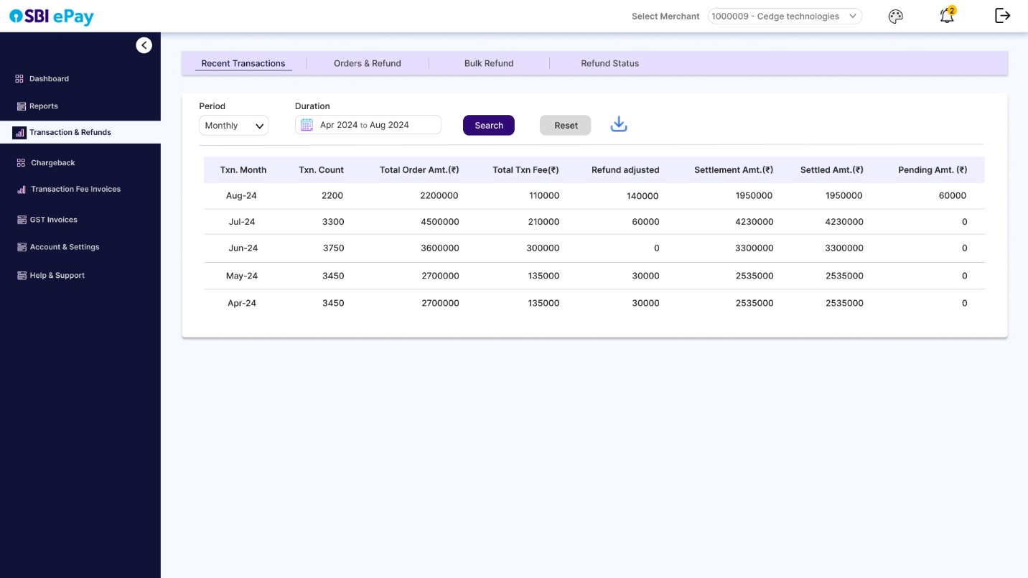

* + - 1. Orders & transactions
* User will refer this tab to search any transaction by merchant order number, SBIePay order ID, ATRN, bank reference number, Duration and Transaction/Order Status.
* By default no value will be selected in any of the parameters.
* User will select at least one of the above parameters and will click on search to display the search results matching the search query. E.g. If user searches an order ID against which 3 transaction attempts were made, all the three transactions will be displayed as search result with their corresponding statuses.

**Important Note**- As per transactions flow, 1 merchant order number can have max 3 SBIePay Order ID, and one SBIePay Order ID can have max 3 ATRNs.

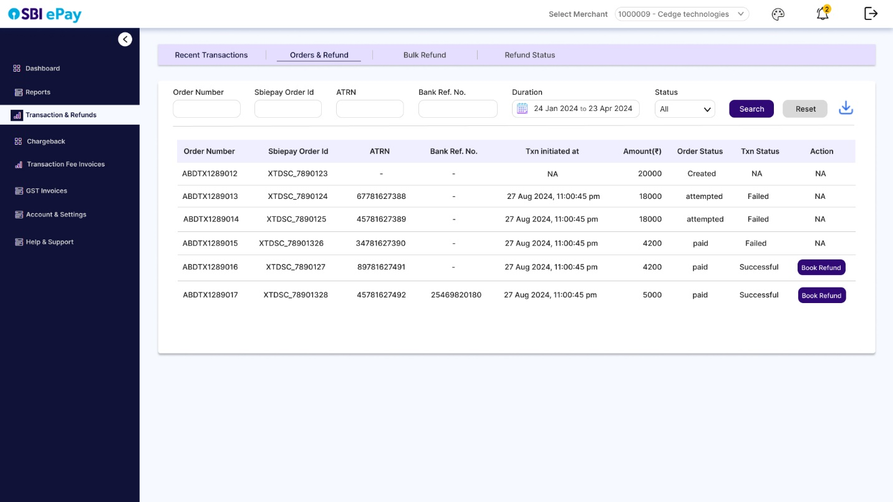

* The search results will be arranged in a tabular format with columns Order Number, SBI ePay order ID, ATRN, bank reference number, transaction initiated at, amount, order status, and transaction status.
* Clicking on search button will display all the results matching the search query in the table below.
* Clicking on reset will reset all the search fields and dropdowns.
* User can download the search results in excel/csv by clicking on download icon.
* User can initiate refund for eligible transactions by clicking on ‘Book Refund’ option in front of each transaction, in ‘Action’ column.
* Clicking on ‘Book Refund’ button will open a drawer from right, asking the user to select the refund type. (Partial or Full refund).

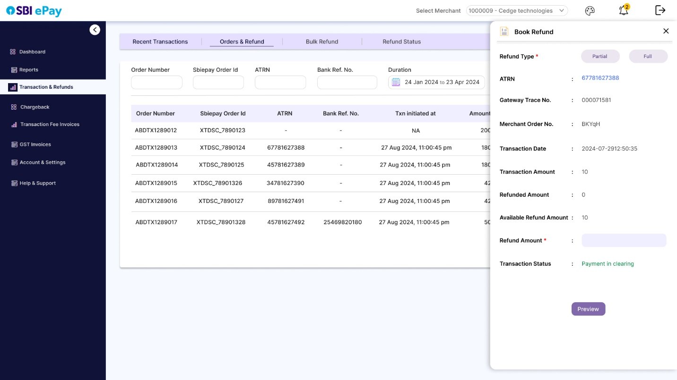

* If partial refund is selected, user can enter the refund amount in “Refund Amount’ field.

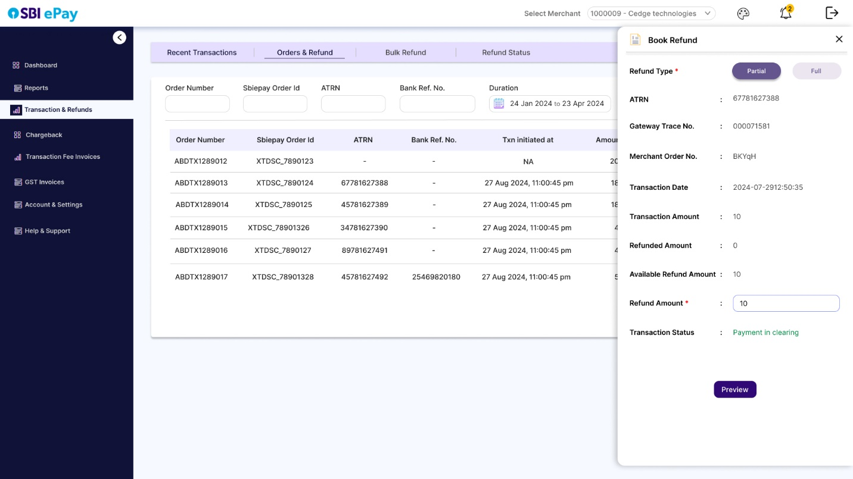

* If full amount is selected, the refund amount will be populated automatically.

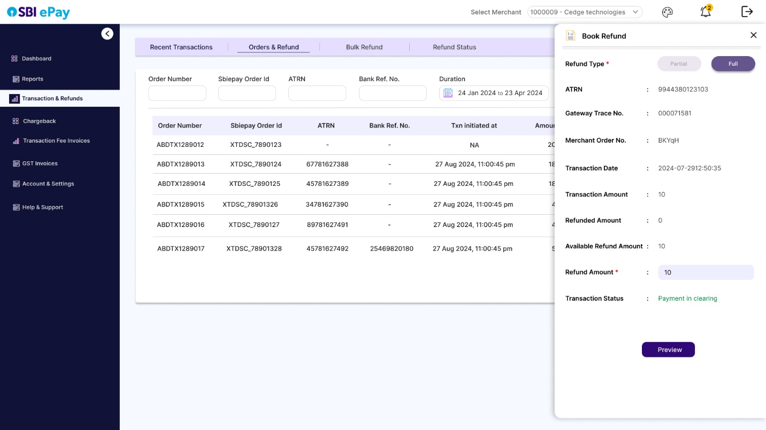

* User will click on ‘Preview’ button to view the preview of refund before submitting.

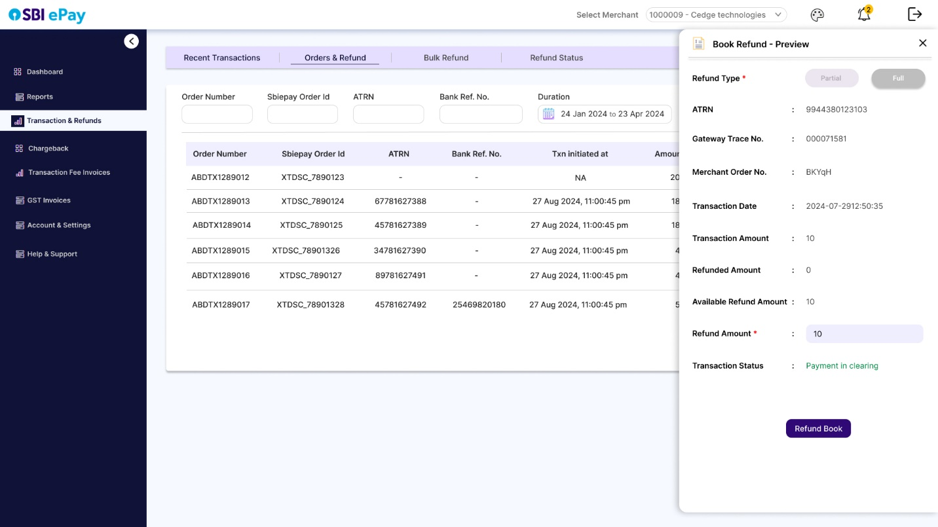

* On Clicking ‘Book Refund’, the refund ID will be created for the transaction.
  + - 1. Bulk Refund

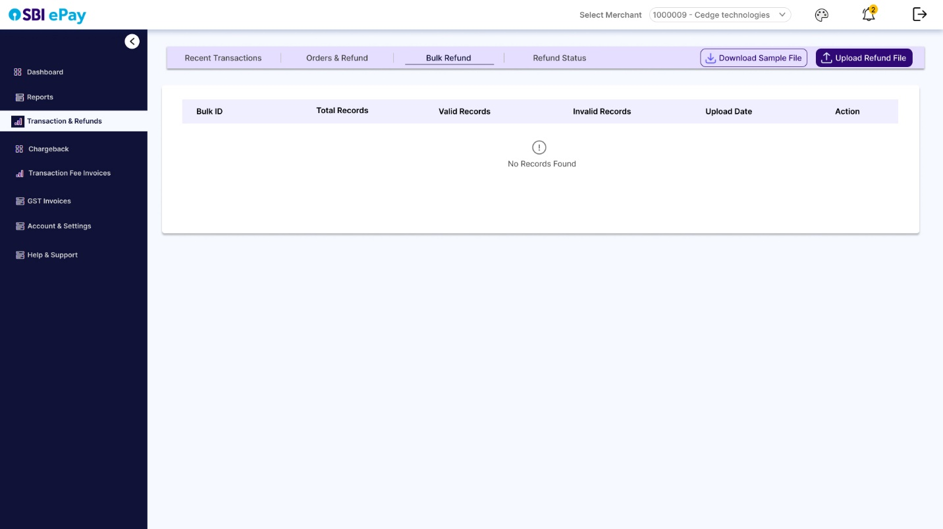

* Bulk refund tab will have a sample excel/csv format file that user can download and refer.
* User will fill in the details of multiple refund entries in sample format and will click on ‘Upload refund file’.
* A drawer will be opened from right side of the screen with a ‘Browse file’ button.

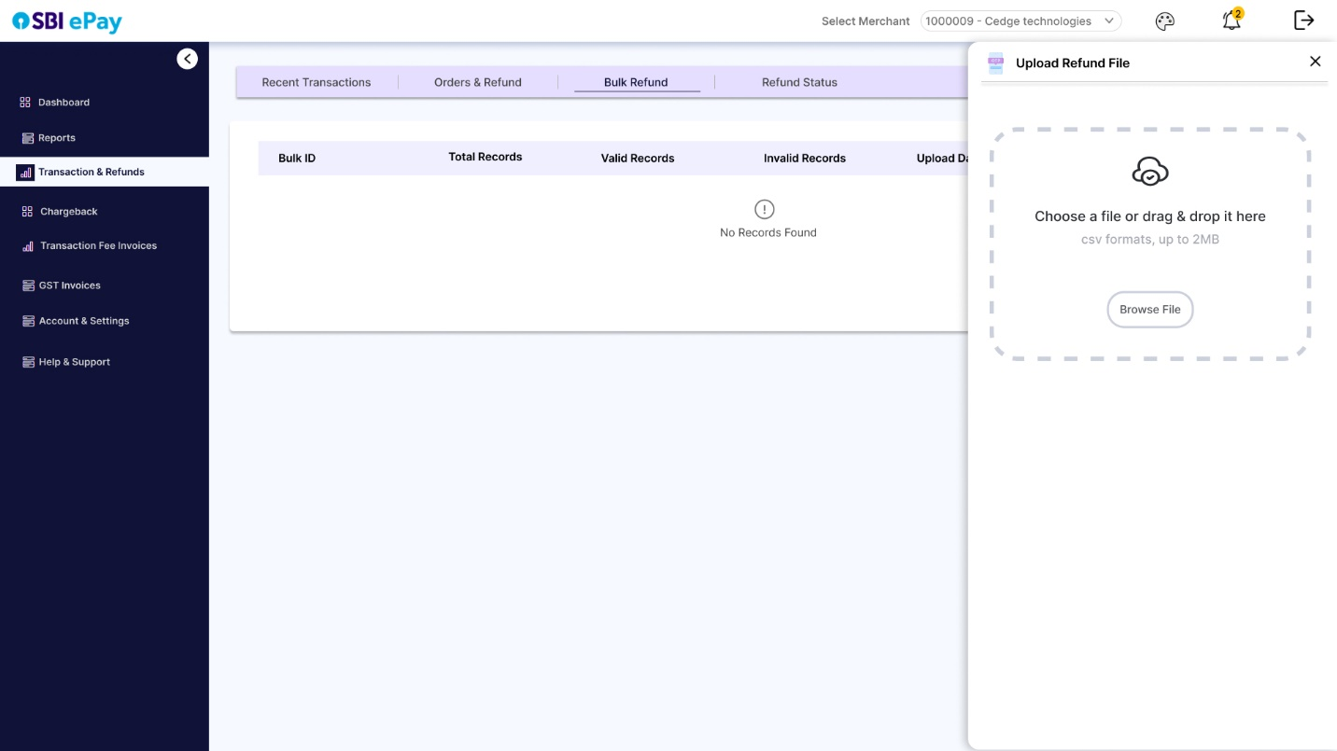

* User will select the excel/csv bulk refund file and will upload the same.

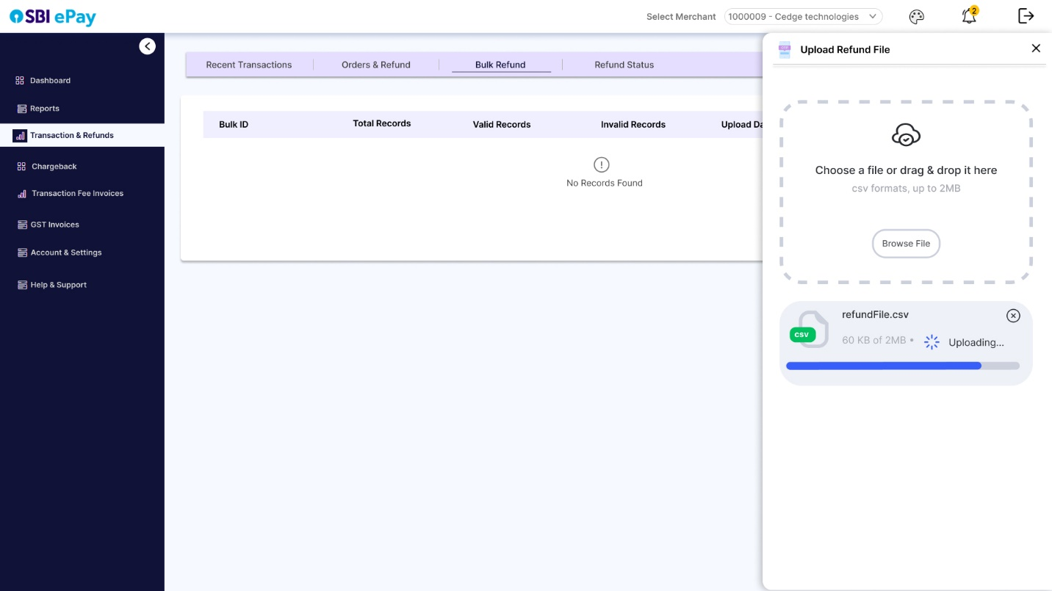

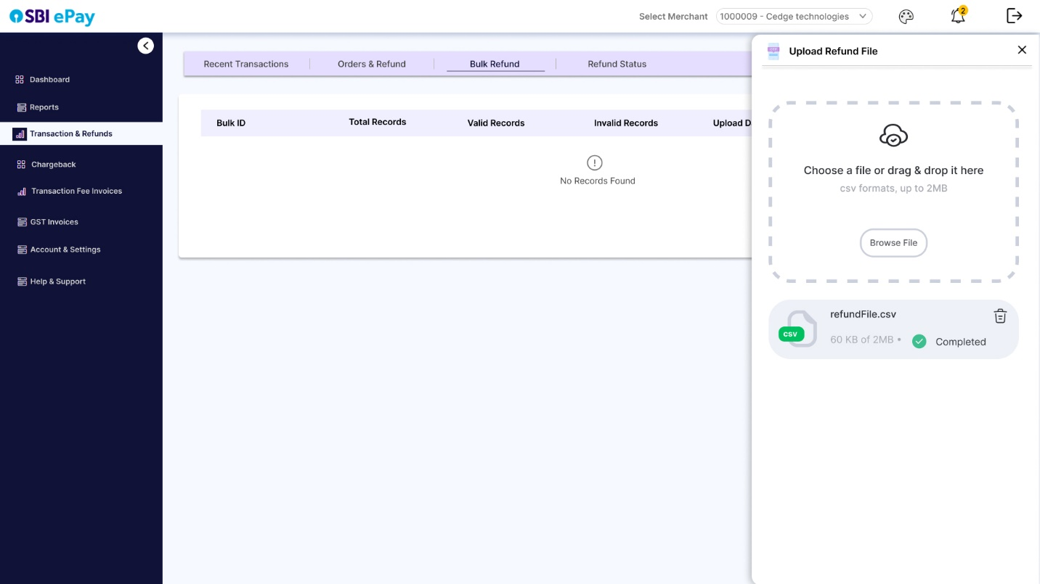

* After the file is successfully uploaded, a bulk refund ID will be created and will be visible in bulk refund table.

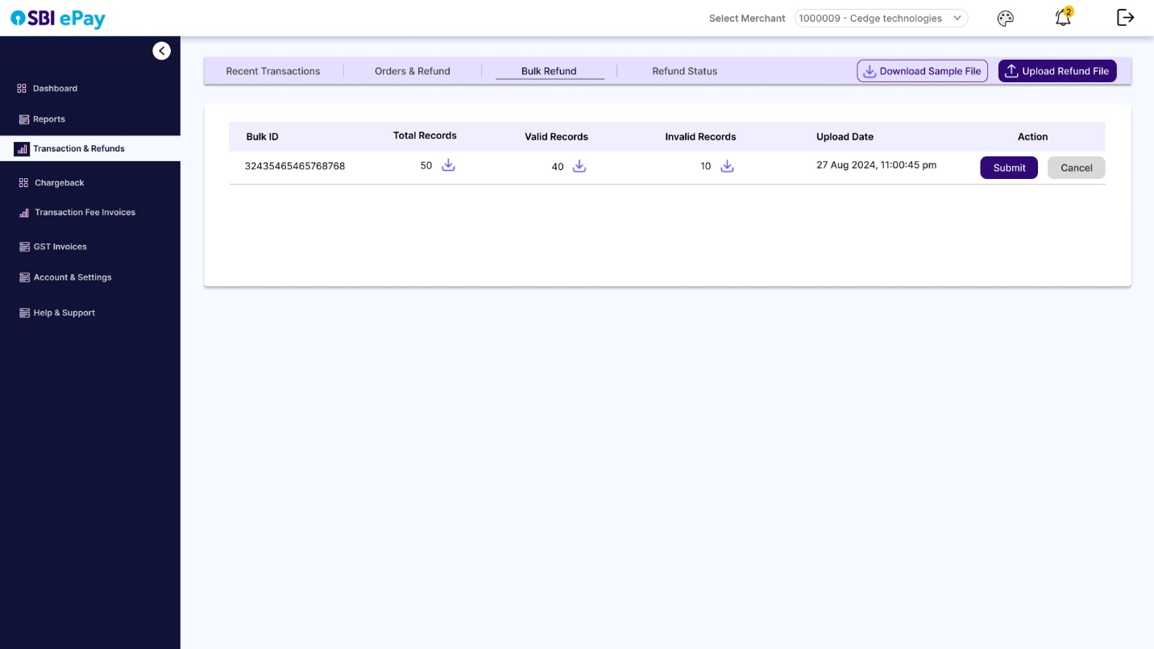

* User will also find the number of valid and invalid records that can be downloaded to view in detail.
* The original uploaded file can also be downloaded by clicking on download icon next to ‘Total records’.
* User can now click on ‘Submit’ to initiate refund only for valid records, or can click on ‘Cancel’ button, correct the invalid records in uploaded file and upload it again and then click on ‘Submit’.
* After submit button is clicked, following screen will be displayed where user can download report of refund initiated transactions, and Refund reference number will be created for the valid refunds.

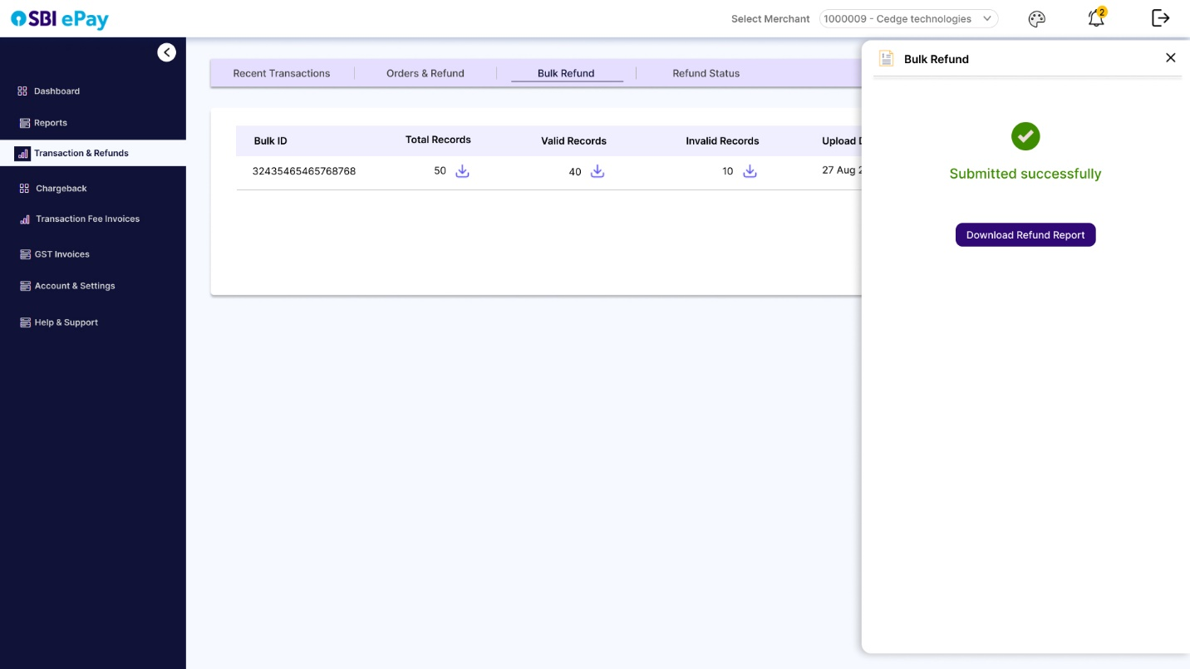

* When user clicks on ‘Bulk Refund’ tab, latest 20 file records will be visible.
  + - 1. Refund Status

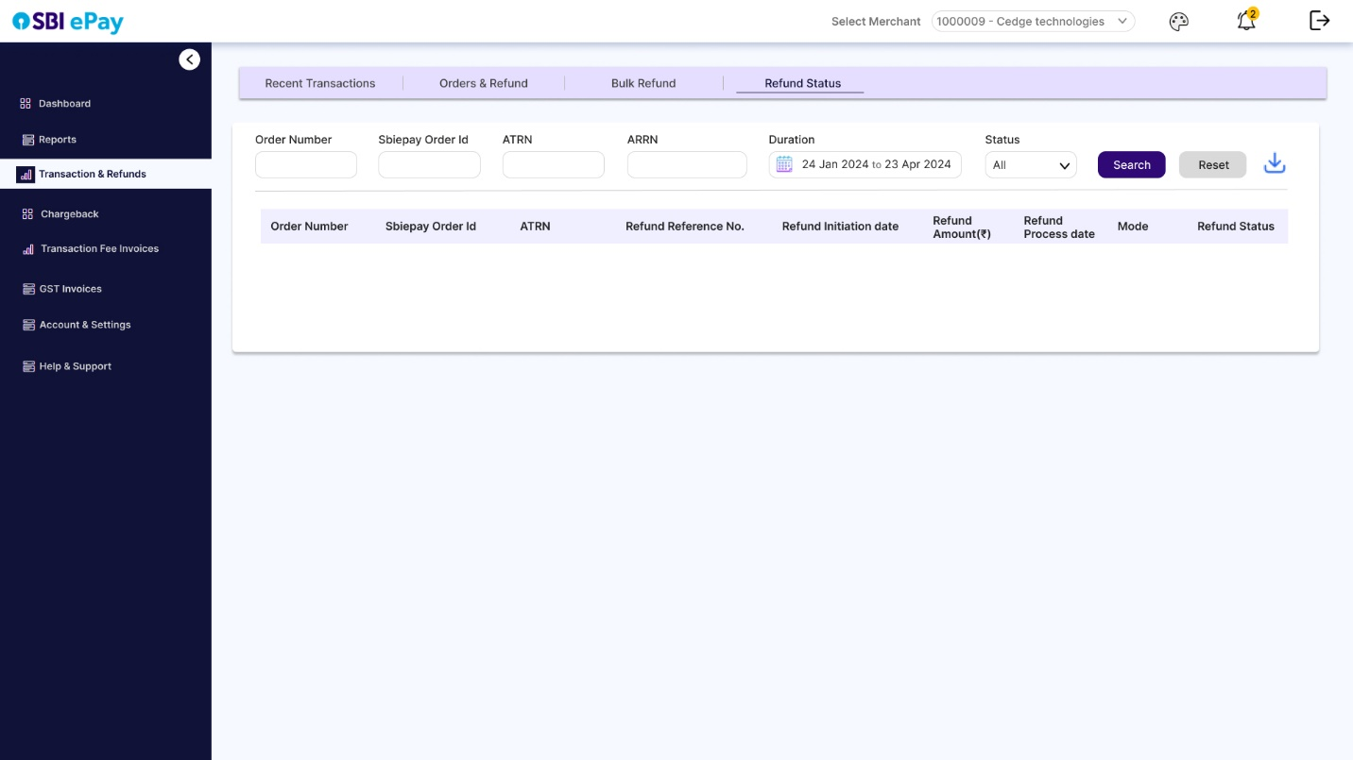

* This tab will function same as ‘Orders & Transactions’ tab, but will be only for transactions against which refund is initiated (refunds in process, successful or failed).
* By default, all the parameters will be blank and no results will be displayed.
* User can search refunds basis parameters like Order number, SBIePay order ID, ATRN, ARRN, Duration and refund status.
* Clicking on search will display all the results that match the search criteria, in the table below.

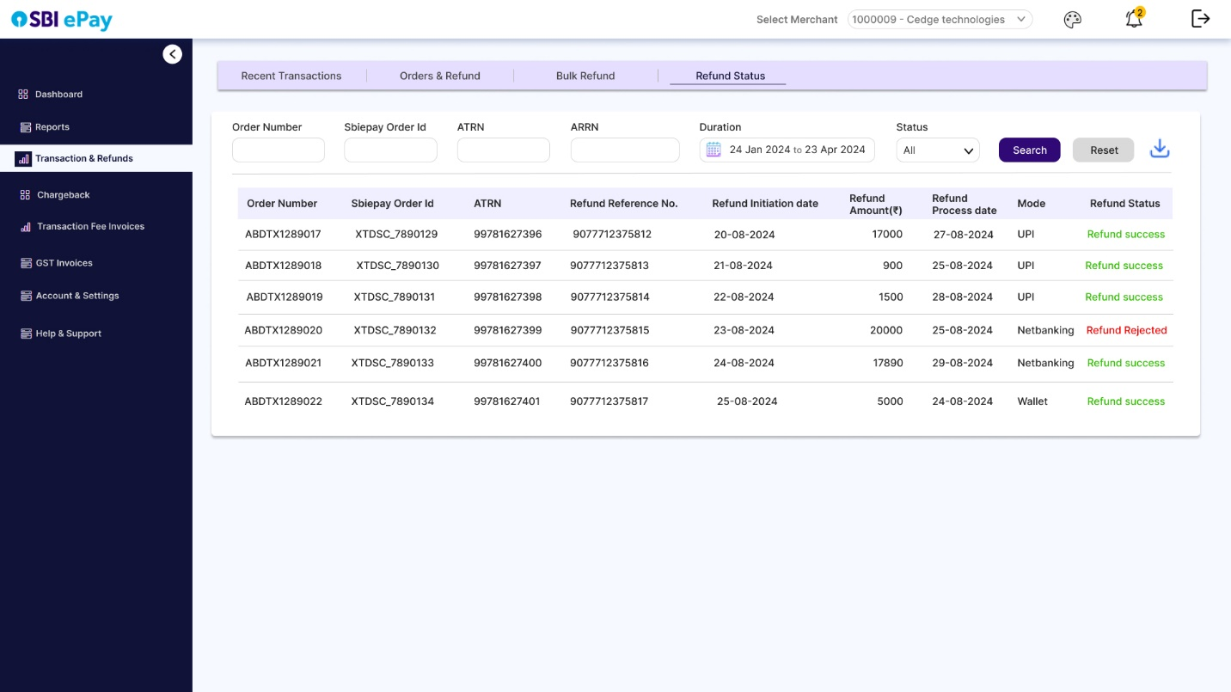

* Results will be displayed in columns such as Order Number, SBI ePay order ID, ATRN, ARRN, Refund initiation date, refund amount, mode and refund status.
* User can click on download to download excel/csv with results displayed in table.
* Clicking on ‘Reset’ will reset all the search parameters.
  + 1. Invoices

1. Transaction Fee invoices

* User will be able to see and download generated transaction fee invoices as per existing system.

1. GST invoices

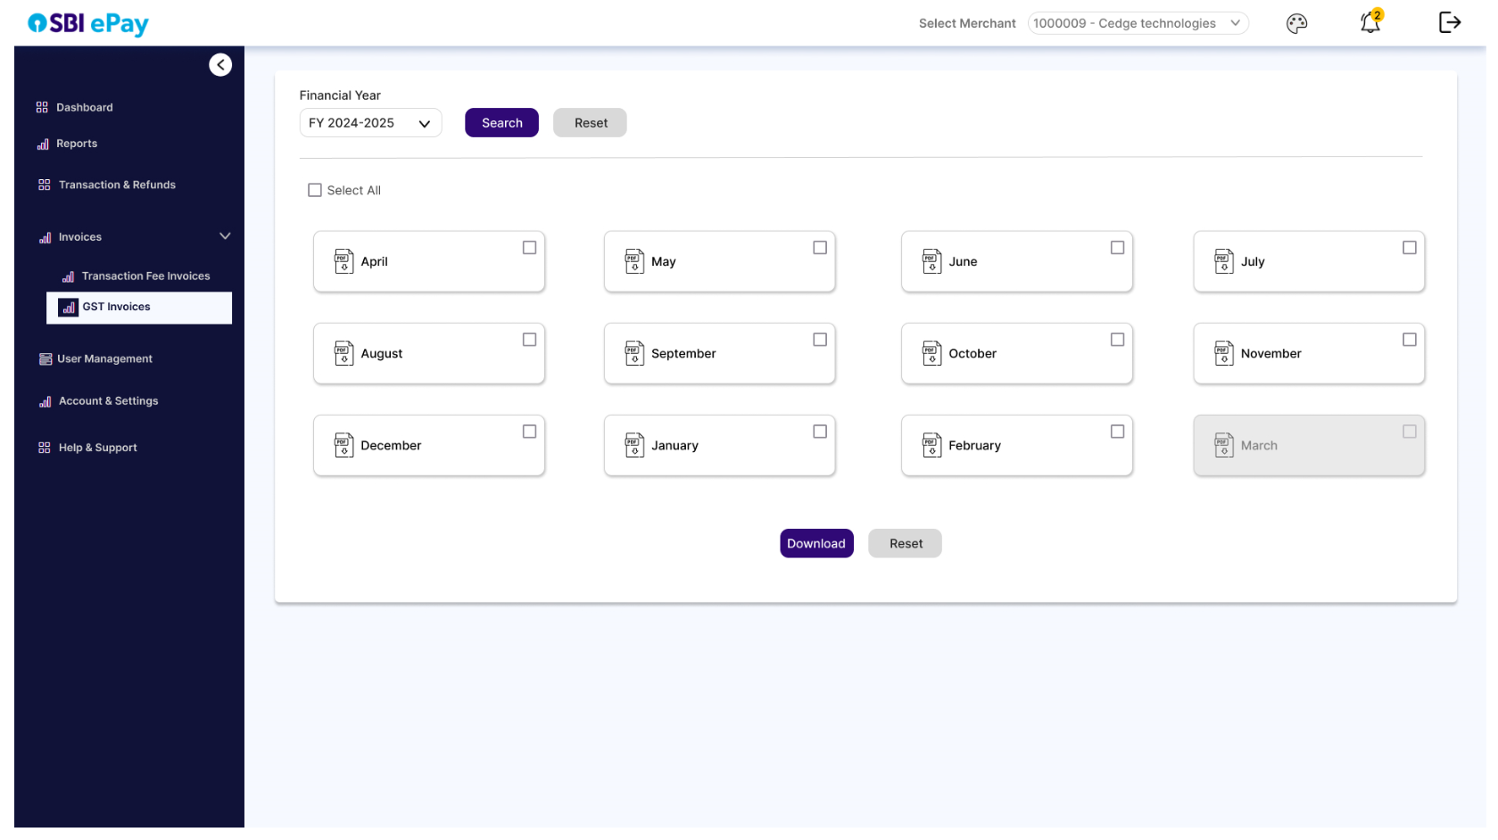

* User will be able to select desired financial year, one or multiple months from the selected year, and click on download to download the GST invoices.

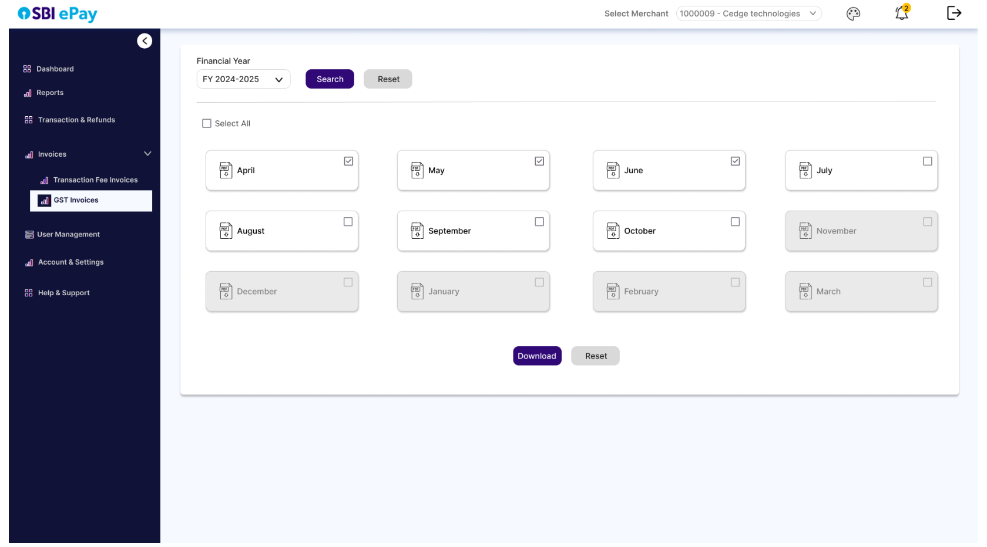

* + 1. User Management
       1. Roles Hierarchy
       2. Details

**Concept of Entity ID-**

We will be introducing a concept of entity ID to system so that new MID can be added to an existing entity ID, or multiple MIDs can be grouped under a new entity ID.

**Existing Entity ID selection for new MID-**

* Every time a new merchant is on-boarded, we will create an Admin for that merchant and will provide admin login credentials.
* Admin can create new users and map tools to them.
* As soon as an MID is formed, we will be asking user if the new MID needs to be mapped for an existing entity ID or not.
* If user selects yes, then they can enter the existing entity ID and click on submit to map new MID under existing entity ID. [What should be validation when MID is linked to an Entity ID?]
* Automatically, new admin created for this new MID will be mapped under the existing entity ID and its SuperAdmin.

**New Entity ID creation for existing MID-**

* If an entity of multiple existing MIDs needs to be formed, (suppose for MID M1, M2, M3 and M4) a maker tool will be created in admin panel to select the MIDs that need to be grouped (mandatory), create a new SuperAdmin for them or select an existing Admin from them to make him/her as SuperAdmin (mandatory) and submit the request.
* In the checker tool (SBIepay Admin panel), SBIePay admin user can approve/decline this request of grouping MIDs and its SuperAdmin mapping.
* Upon approving this request, a common Entity ID will be created for grouped MIDs and their main user will be the SuperAdmin.
* In the same tool, a provision will be kept to add/remove MIDs and SuperAdmins to an existing entity ID.

**Note**: Concept of Entity ID and SuperAdmin will not be applicable for single MID which are not part of any group / entity.

**Roles and Responsibilities-**

1. **Superadmin**

* SuperAdmin will be created by SBIePay BU maker (during entity ID creation) and will be approved by SBIePay BU checker. [**VD:** should be marked as root admin. Can be de-activated by SBIePay BU?]
* SuperAdmin will have view and modify accesses to all the functionalities and reports of all the MIDs of the group/entity.
* Superadmin can create new superadmins.
* Superadmin can create new admins and can map single/multiple/all MIDs to each of them
* Superadmin can create new users and can map single/multiple/all MIDs to each of them and all access of all the modules (except user management).
* Superadmin can deactivate superadmins (except those created by SBIePay BU)
* Superadmins can deactivate admins/users (except those created during onboarding by SBIePay BU)
* Superadmin can view the entire user management hierarchy.
* Superadmin can be deactivated only by SBIePay BU Team.
* Superadmins can reset password for all the users under them.

1. **Admin**

* Admins will be created either during onboarding of MID, or later by superadmins.
* Admins can create other Admins but can assign them all/some MIDs from the list of MIDs that are mapped to original admin created by SBIePay BU, and not, other unmapped MIDs.
* Admins can create users and assign only those MIDs which are mapped to them, and can map accesses and rights to them (except user management).
* Admins can view list of users for MIDs mapped to them.
* Admin can be deactivated by Superadmin (except if the admin is created during onboarding by SBIePay BU)
* Admins can reset password for all the users under them.

1. **Users**

* Users will be created by Admins/Superadmins.
* Users will have access of all the mapped functionalities (except user management) of the MIDs assigned to them by Admins/Superadmins.
* Users can be deactivated by admins/Superadmins.
* Users will not get user management view except their own profile edit section.
  + - 1. User management View

A. Profile Tab

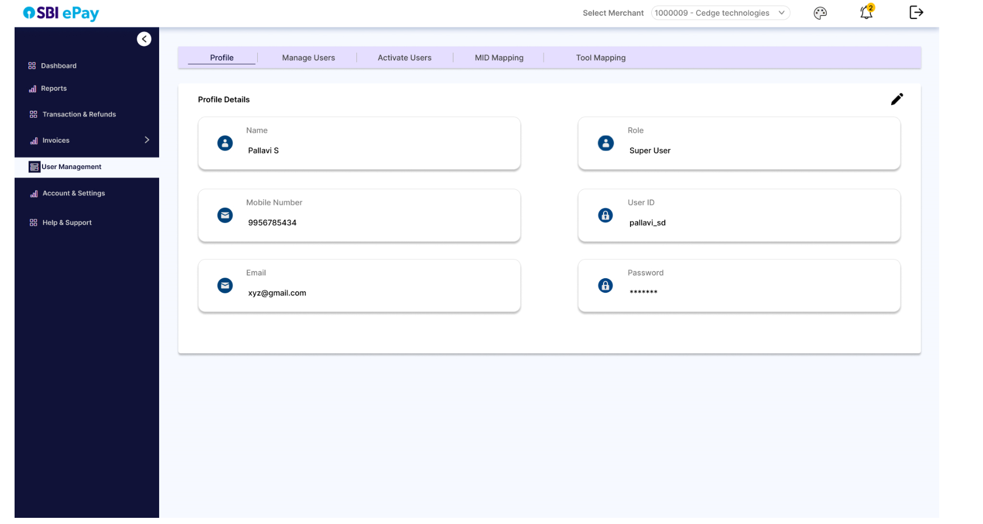

* In this section, user can view and click on edit (as per access) to edit their own profile details, such as name, E-mail ID, mobile number, account password, etc.
* Following will be the screen visible after clicking on edit icon.

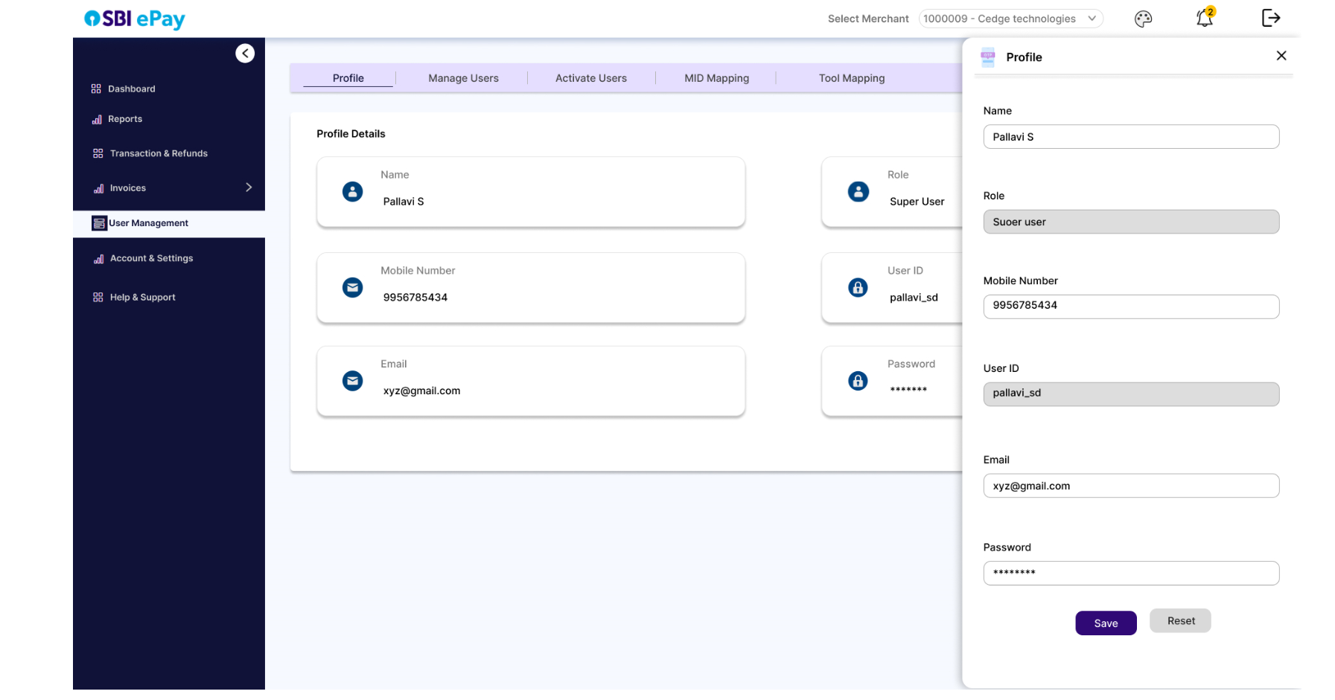

* As per screenshot above, upon clicking on the edit icon, a side panel will open where user can edit their display Name, mobile number, Email ID and can set a new password. (user ID and Role will not be editable.)
* Once user clicks on save, an OTP will be triggered to their registered mobile number and email which they will be asked to enter.

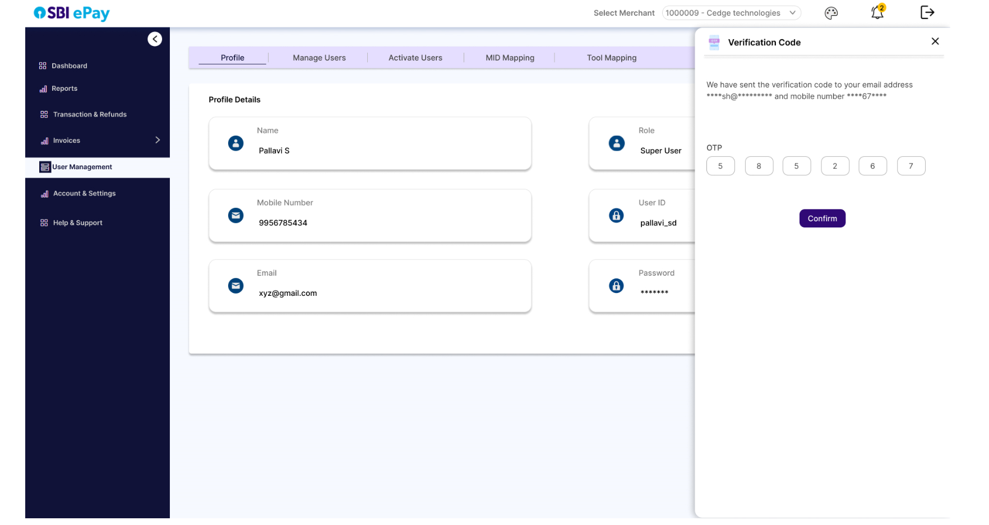

* After entering the correct OTP, and clicking on ‘Confirm’, user details will be saved.

B. Manage Users

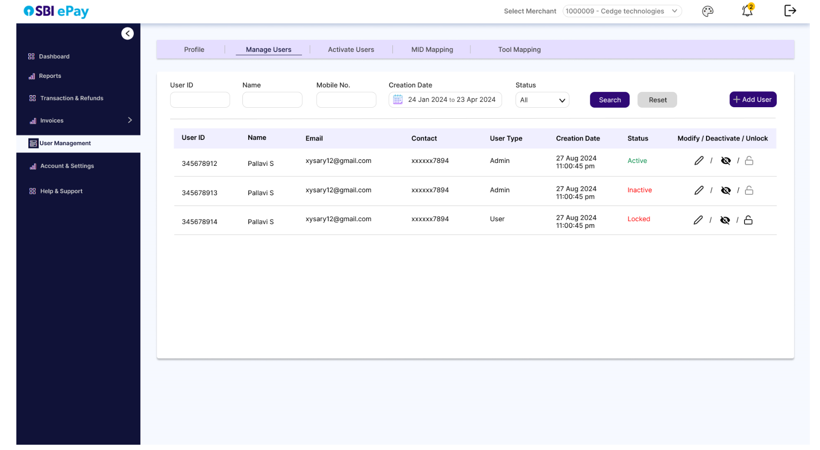

* In manage users tab, user can filter/search users basis their User ID, name, Mobile No, creation date, Status.
* The search/filter results will be displayed in a tabular form with columns such as User ID, Name, Email, Mobile No., User Type, Creation Date, and Status.
* If user has necessary privileges, they can click on pencil icon to modify the details as shown below.

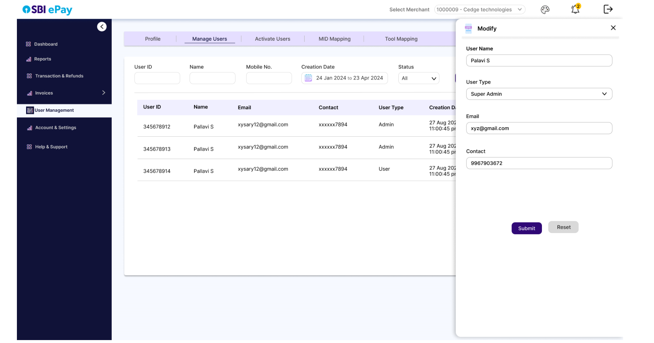

* They will make necessary changes in the side panel that gets opened and can click on ‘Submit’ button to update the changes.
* The user can click on ‘Reset’ to clear all the fields and input new details.
* These new fields will be updated against the username which is not editable.

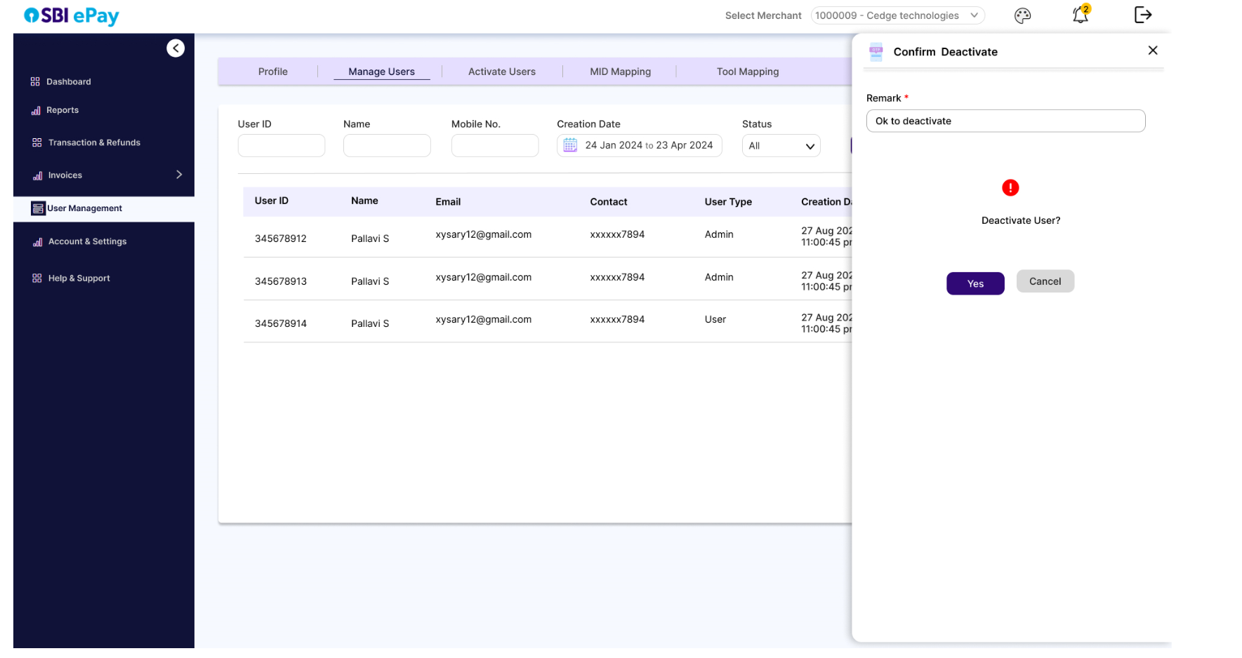

* User can click on ‘Deactivate’ icon to open a side panel that asks confirmation if the user needs to be deactivated.
* Merchant will be asked to enter the mandatory remark for deactivation and will click on ‘Yes’ to deactivate the user.
* Clicking on ‘Cancel’ button will close the side panel.
* Similarly, when user clicks on ‘unlock icon’ which is enabled in front of locked users, user will be asked to confirm unlocking and enter the mandatory remark as per screen below.

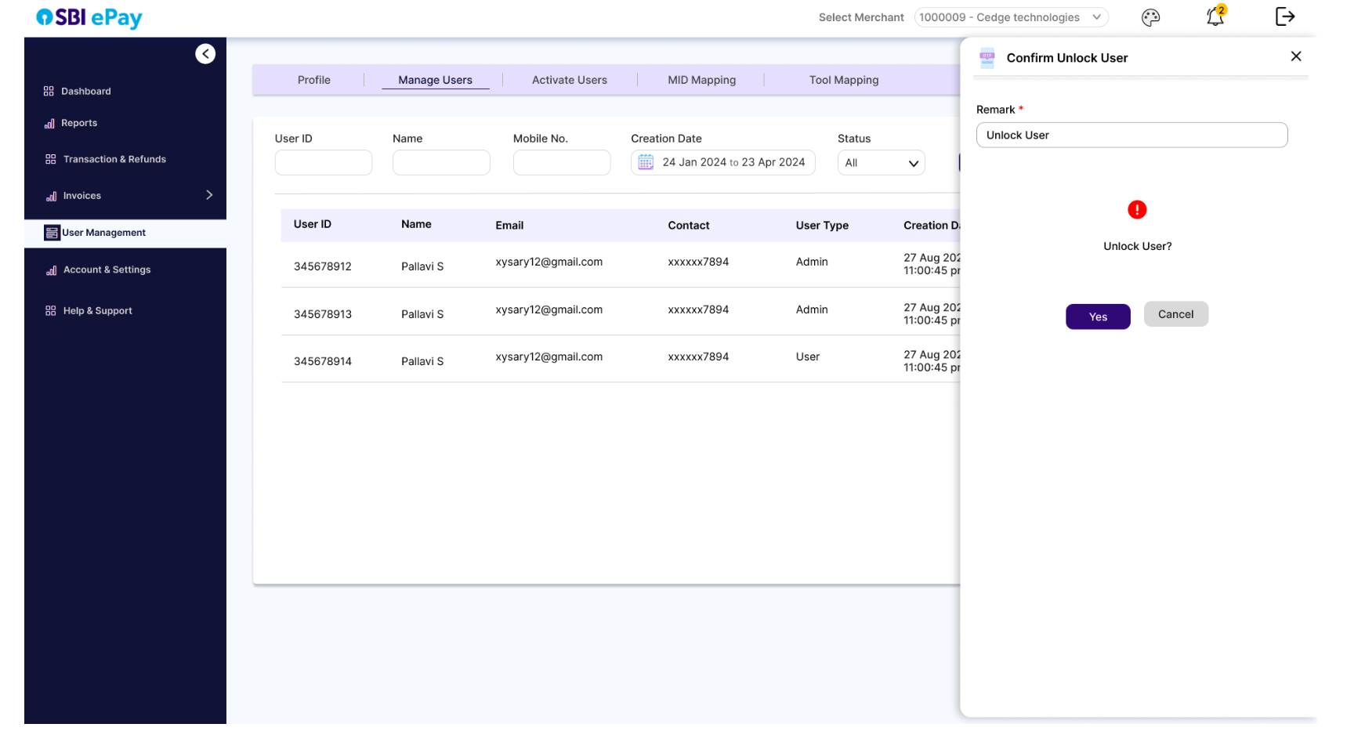

* Clicking on ‘Yes’ without entering the mandatory remark will give error- ‘Please enter remark’.
* Clicking on Cancel will close the side panel.

C. Activate Users

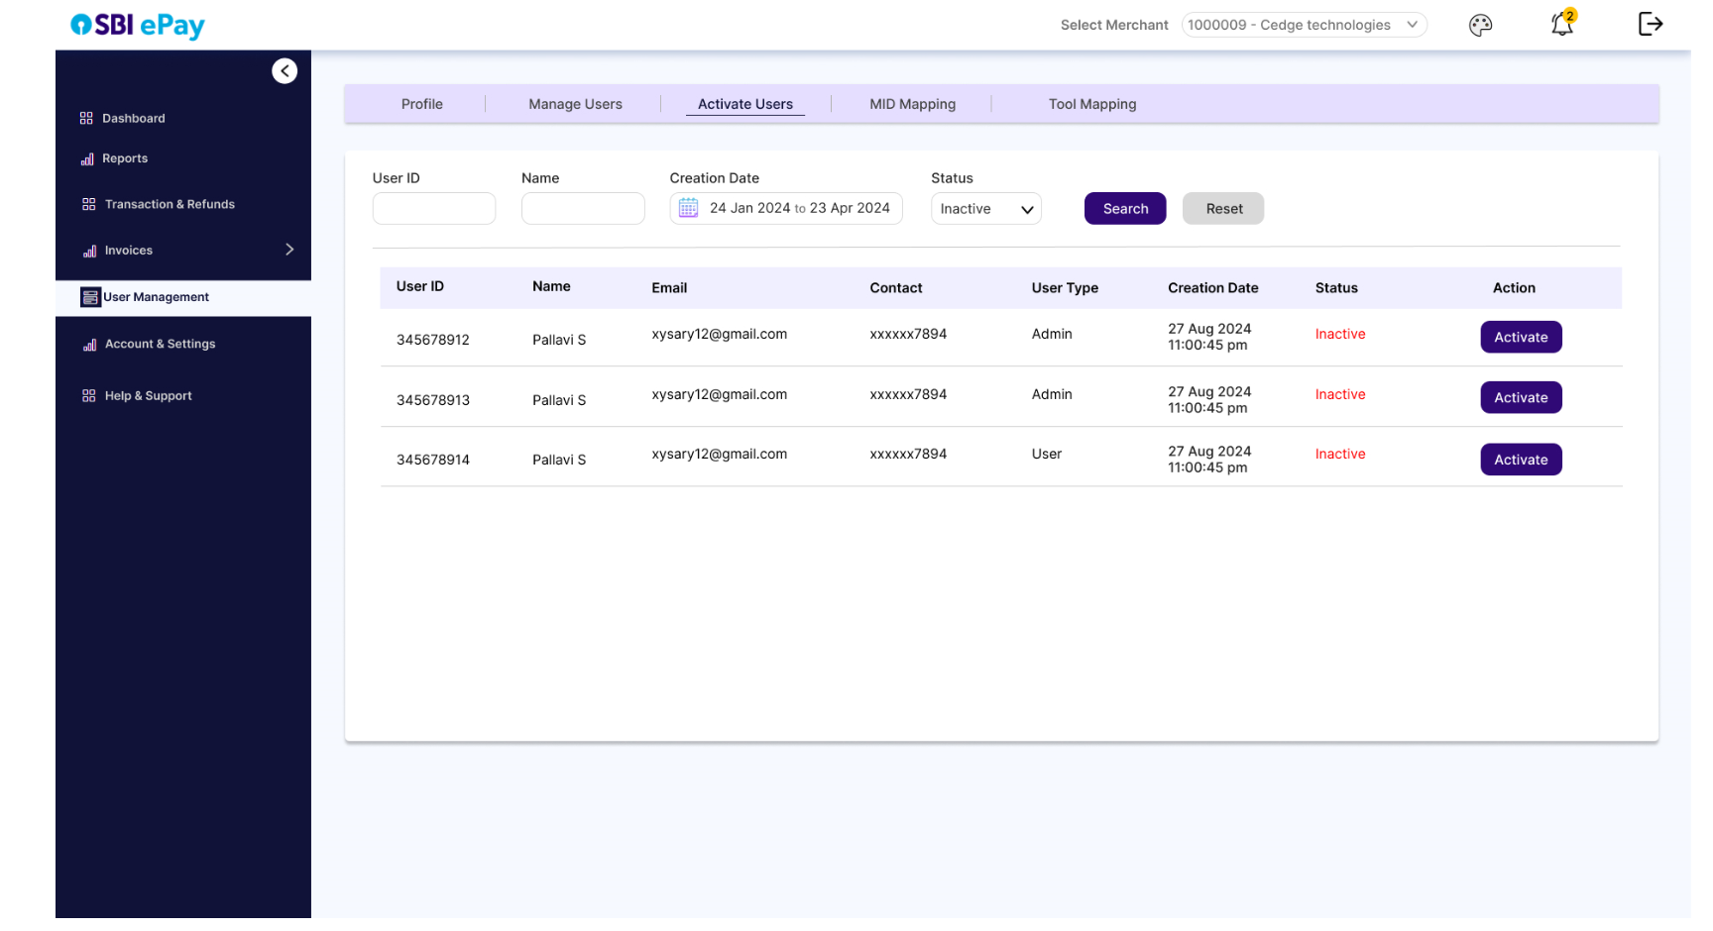

* As per screen above, user will search/filter inactive users in this screen by searching with user ID, name creation date.
* The results will be displayed in a tabular format with columns such as User ID, name, Email, Contact, User Type, Creation date, Status and ‘Activate’ button.
* By clicking on ‘Activate’ button, user will be asked to confirm they want to activate the user.
* 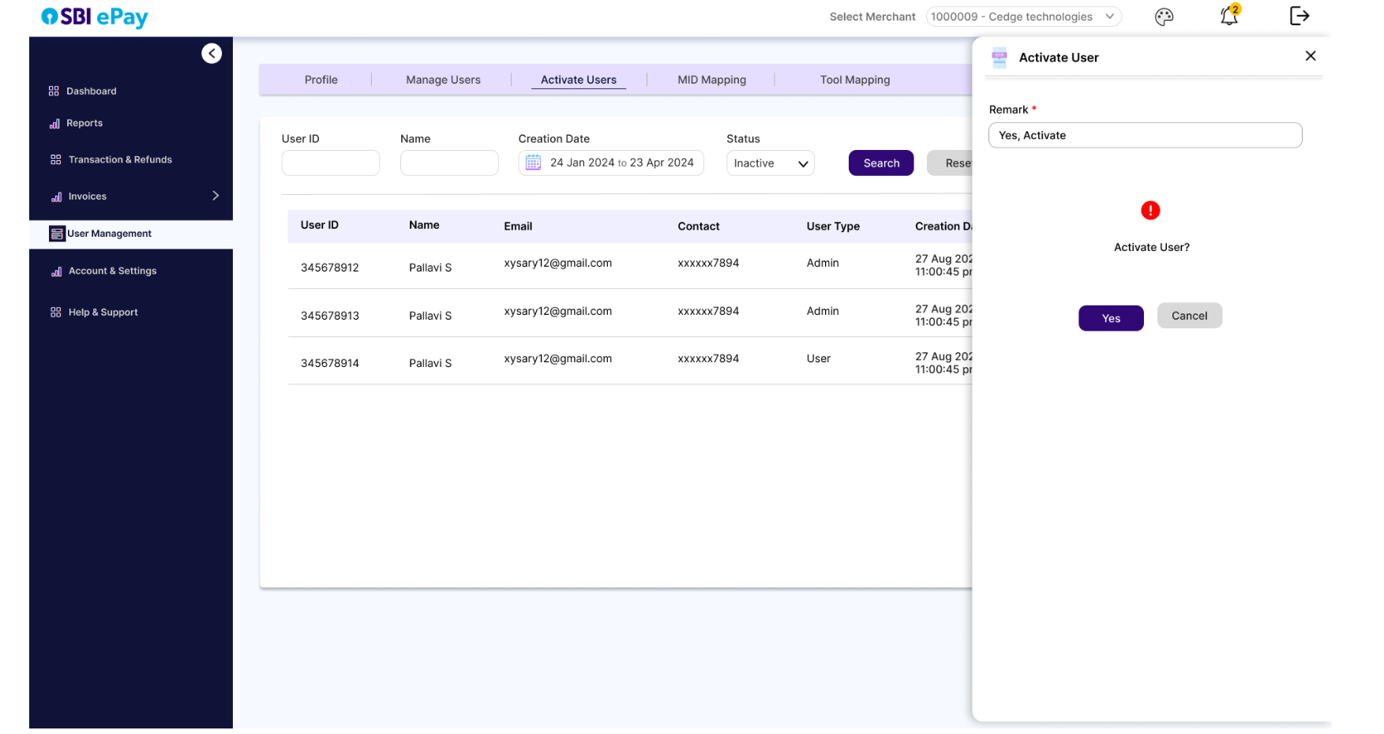
* Clicking on ‘Yes’ without entering the mandatory remark will give error- ‘Please enter remark’.
* Clicking on Cancel will close the side panel.

D. MID mapping

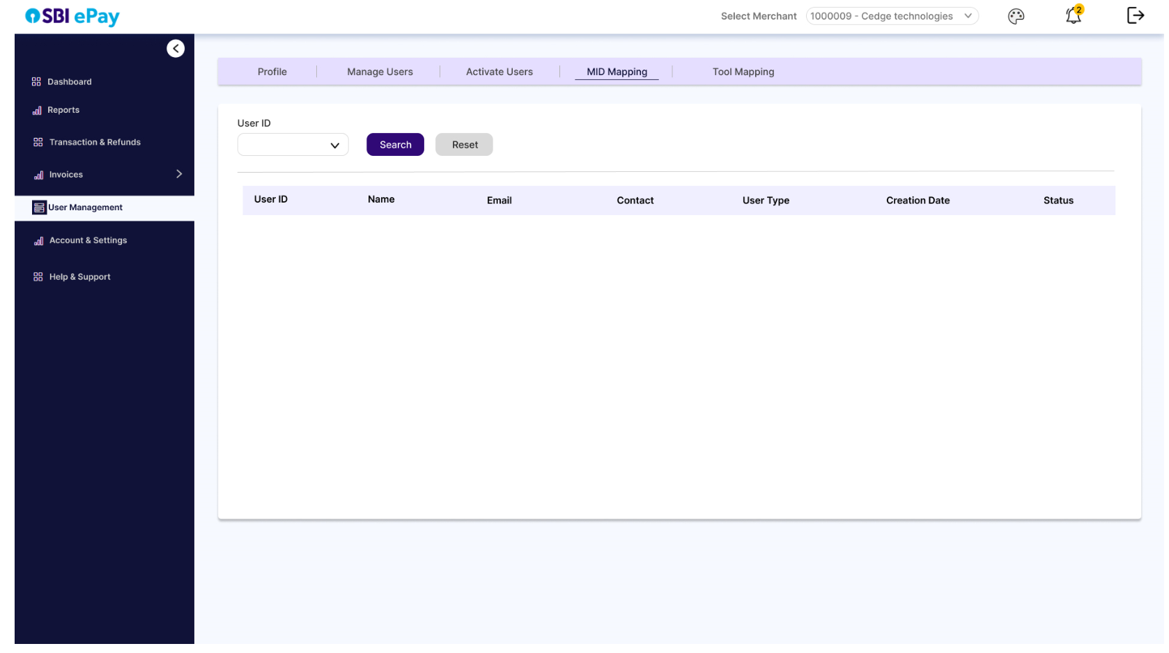

* In this tool, user will first select the user ID from dropdown and will click on search button.

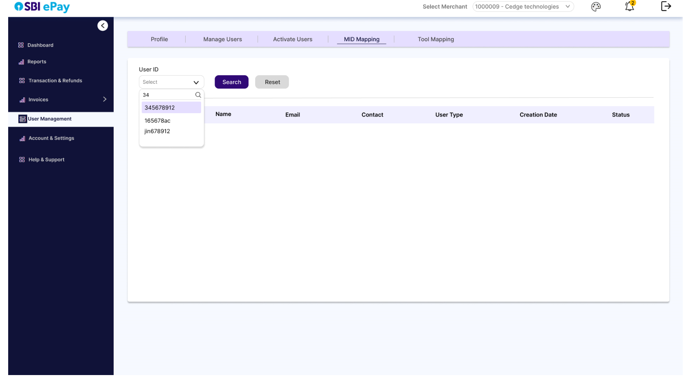

* Clicking on search button will open the Unmapped MID and Mapped MID section.

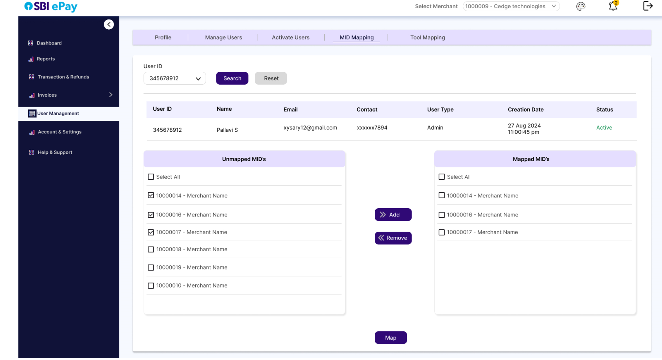

* User can select multiple MIDs and can move it from unmapped MIDs section to mapped MIDs section, and vice versa by clicking on Add or Remove buttons.
* Once appropriate mapping is done, user will click on ‘Map’ button to complete the MID mapping.

E. Tool mapping

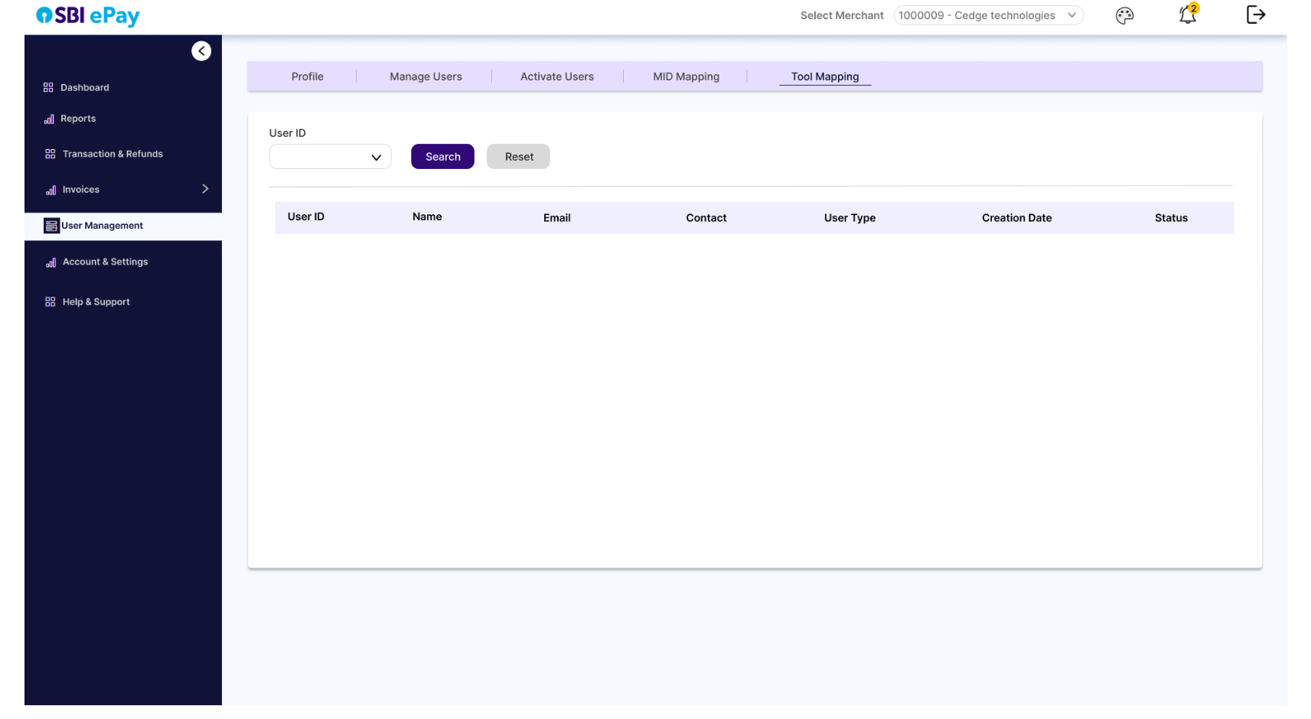

* In this tool, user will first select the user ID from dropdown and will click on search button.

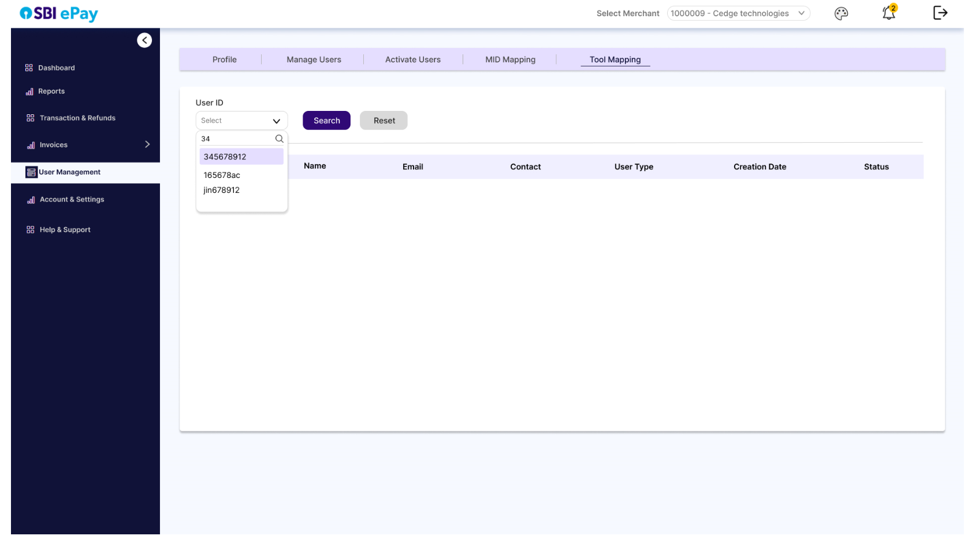

* Clicking on search button will open the Unmapped functions and Mapped functions section.

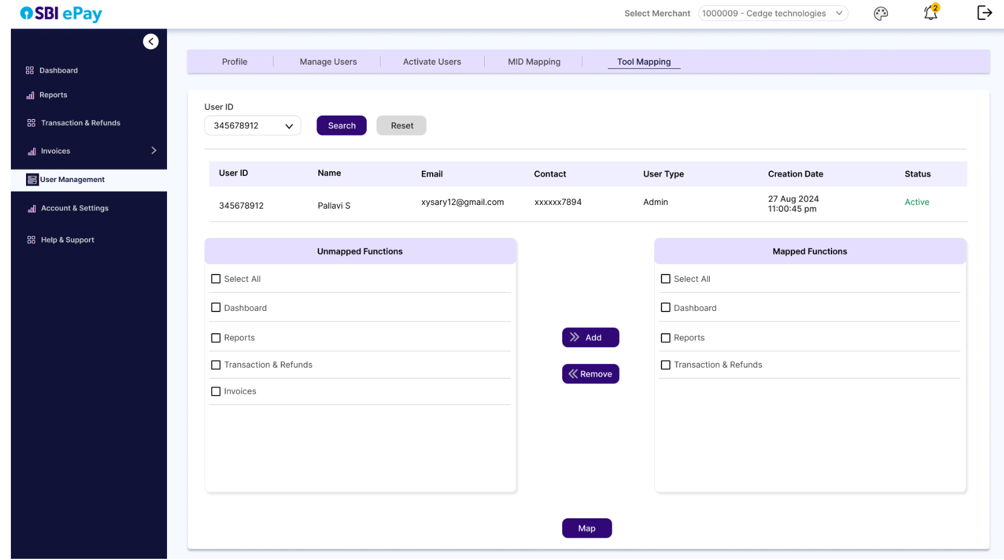

* User can select multiple functions and can move it from unmapped functions section to mapped functions section, and vice versa by clicking on Add or Remove buttons.
* Once appropriate mapping is done, user will click on ‘Map’ button to complete the MID mapping.
  + 1. Account & Settings

Account & Settings menu will have following options-

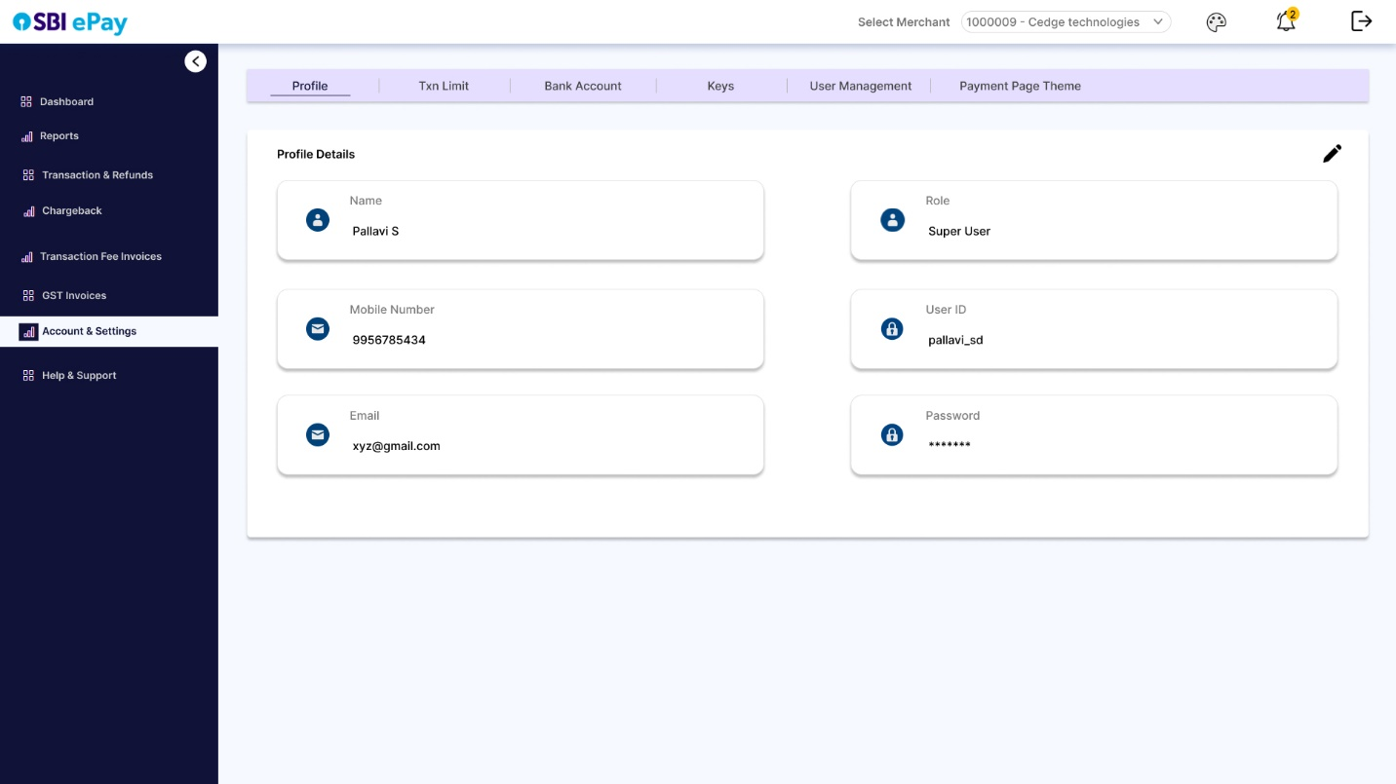

* In this section, user can view and click on edit (as per access) to edit their profile details, such as name, E-mail ID, mobile number, account password, etc.

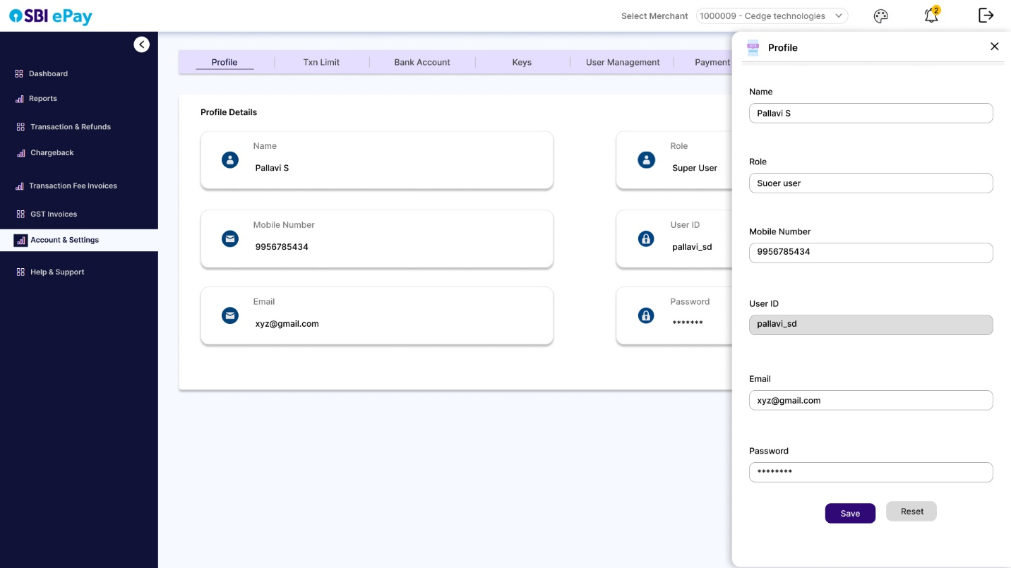

* Once necessary changes are made and ‘Save’ button is clicked, a verification code will be sent on user’s E-mail ID and mobile number.

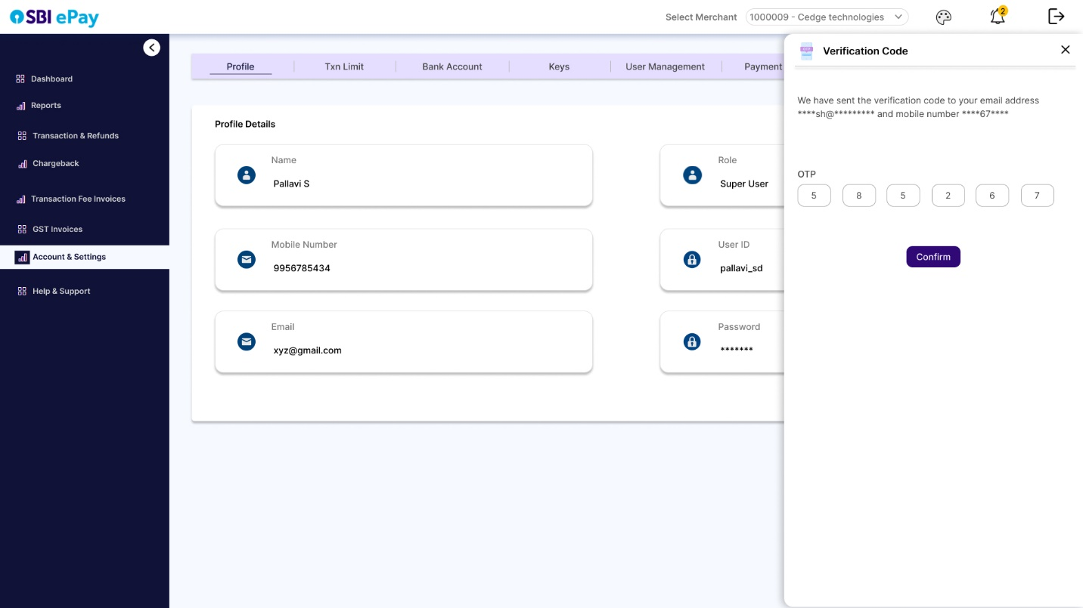

* User can enter the verification code received, and click on ‘Submit’ to save the changed details.

1. * 6. 1. Transaction Limit

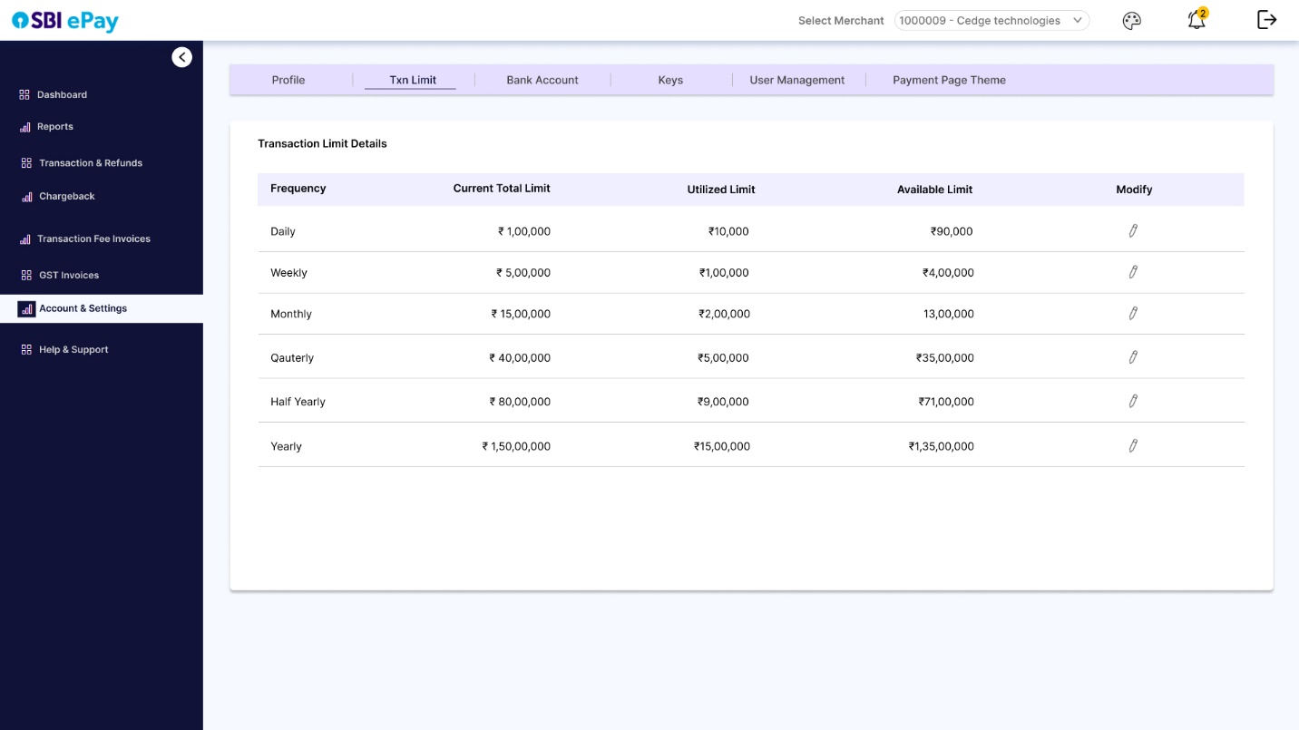

* User will be able to see current configuration of transaction limit for each frequency in ‘Current Total Limit’ column.

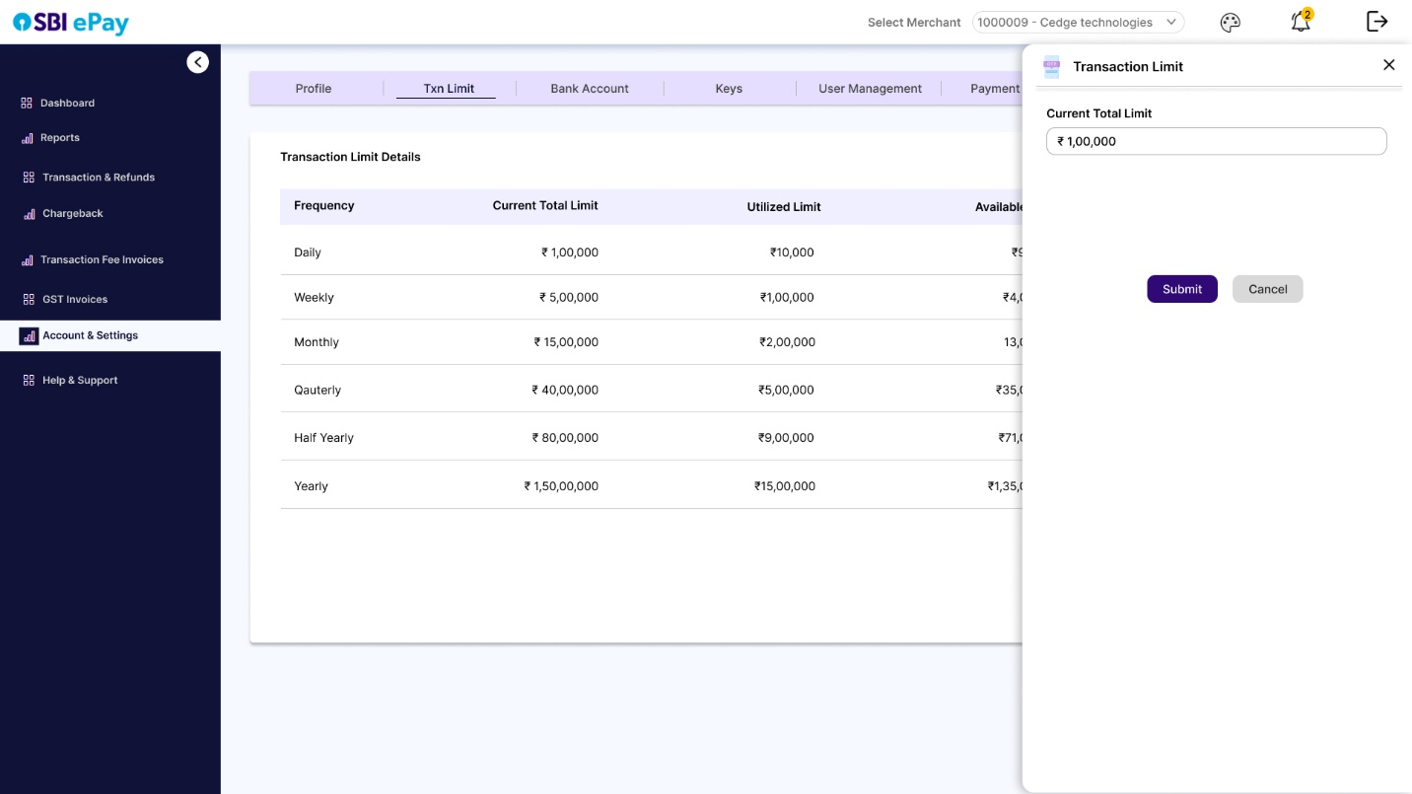

* User will be also shown ‘utilized limit’ and ‘available limit’ for each frequency for ongoing cycle.
* User can refer this information and can click on ’Modify’ option for any frequency to open a drawer from right side to edit the limit and submit the same.
  + - 1. Bank Account

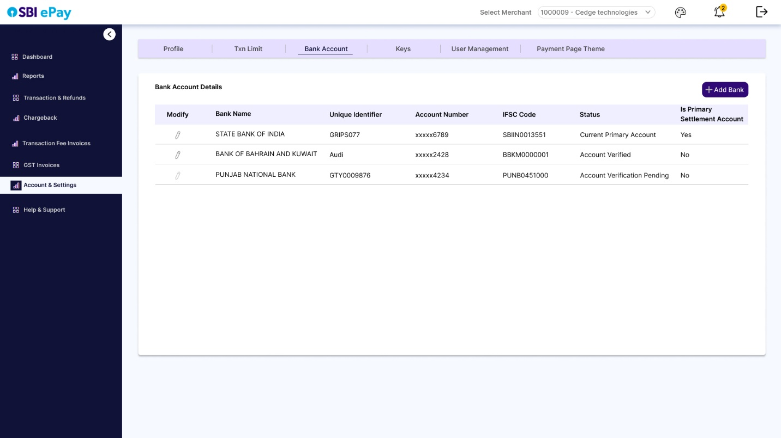

* In this section, user will be able to view and edit (as per access) the bank accounts added for settlement.
* User can click on ‘Add Bank’ button to open a drawer with all the fields required to add a new bank.

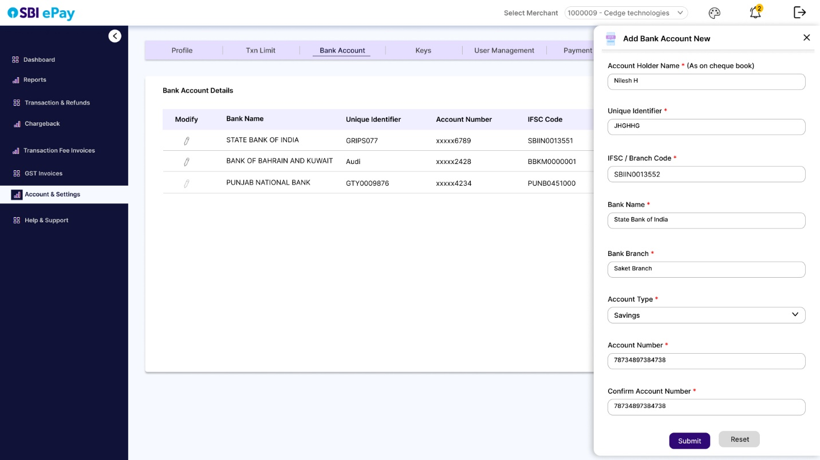

* After all the details are filled, ‘Save’ button can be clicked to ‘Submit’ the newly added bank.
* ‘Reset’ button can be clicked to reset all the fields and start afresh.
* User can click on ‘Modify’ icon present in front of each banks for following three activities-

A. To edit the bank account details

B. To make the bank account primary for settlement.

C. To deactivate the bank account.

D. To activate the bank account.

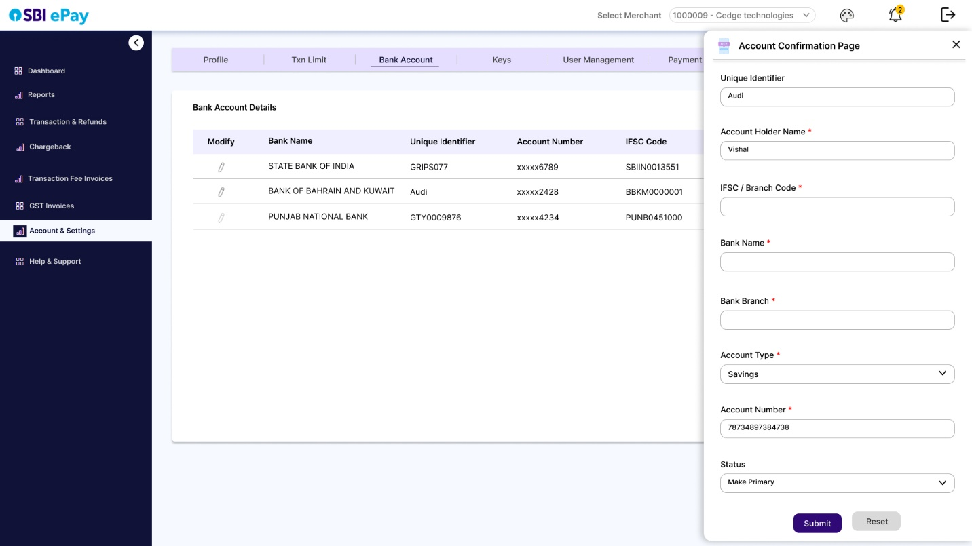

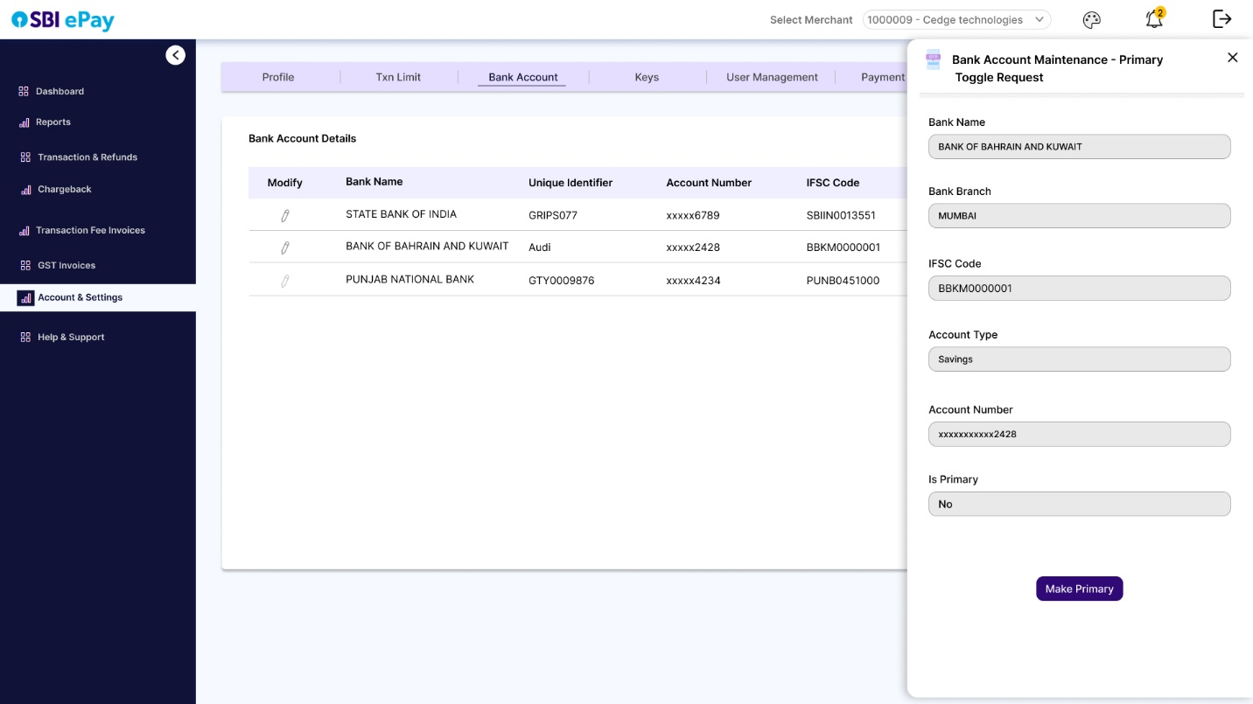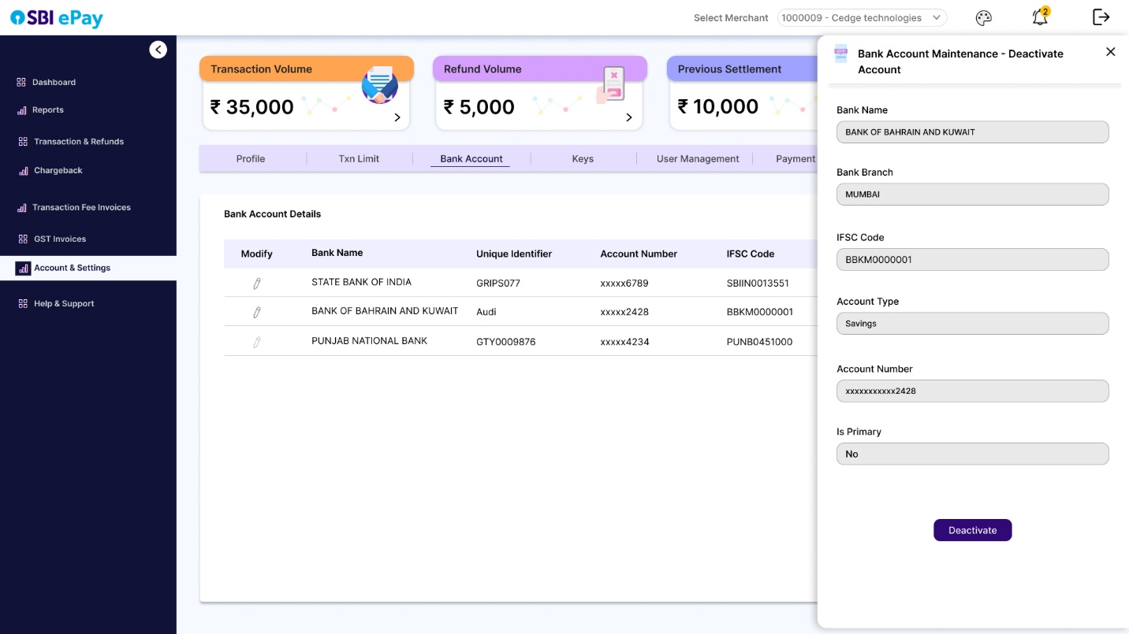

* At any point of time, only one account can remain primary for a single account merchant.
  + - 1. Keys

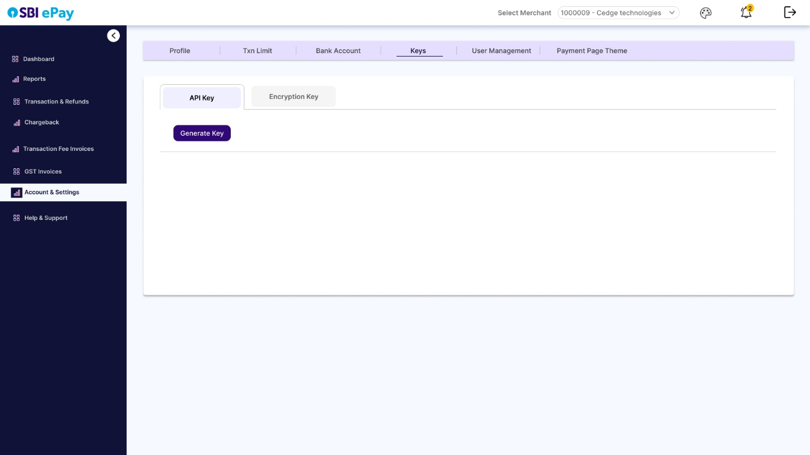

* User can generate or regenerate keys using this section.
* When user visits this section, they will see two sections, API Key and Encryption key.
* For any of the two key sections, user can click on ‘Generate key’ option to enter a drawer that will ask user to enter Key ID and Secret key.

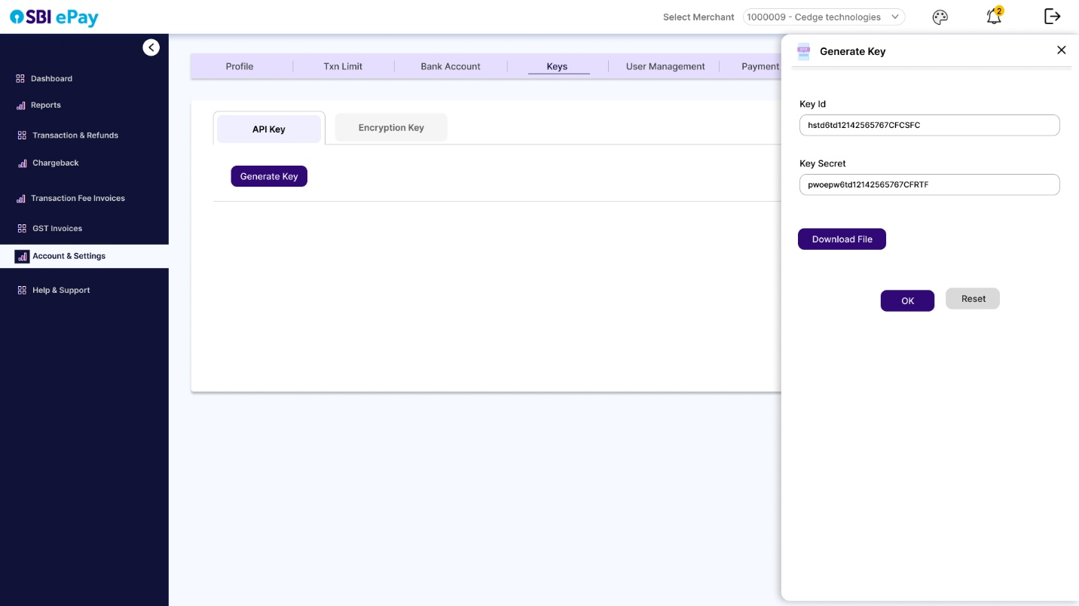

* User can enter these fields and click on ‘OK’ to generate the same, and download the key file (password protected).
* ‘Regenerate key’ can be clicked to generate the key again.

Note: Wherever Key is displayed in UI, it will be masked with a copy button

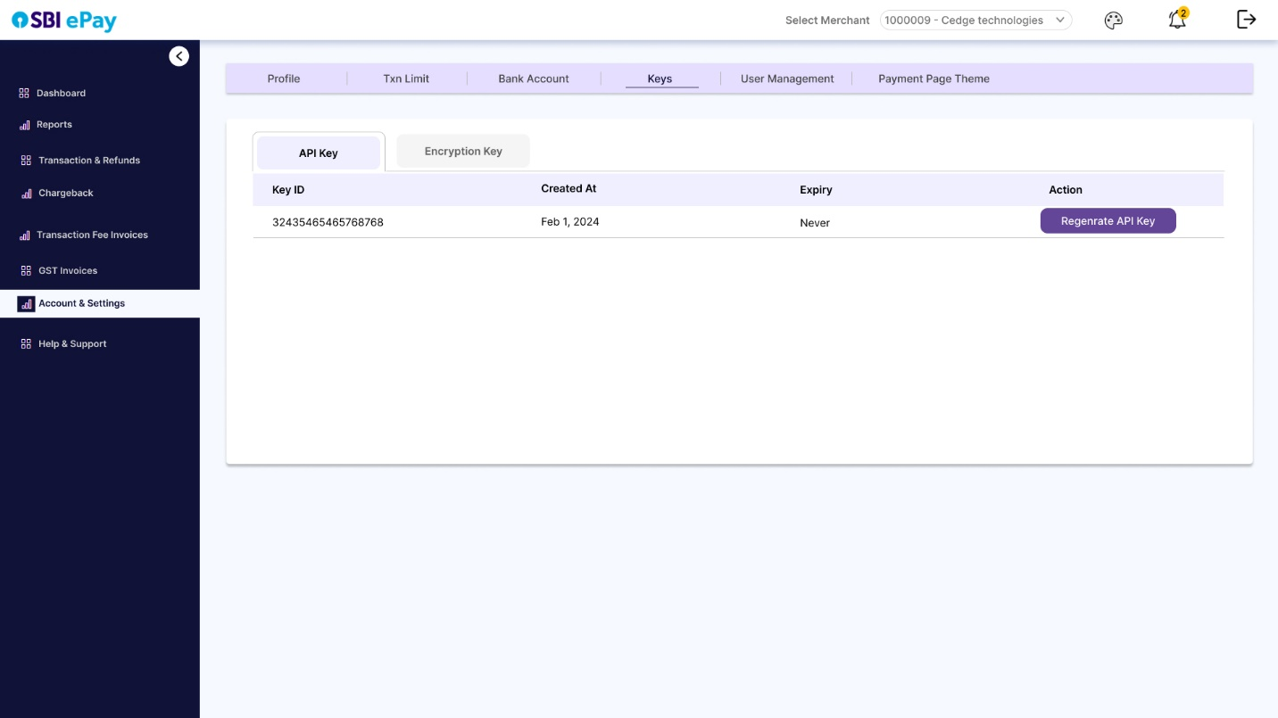

* + - 1. Payment Page Theme

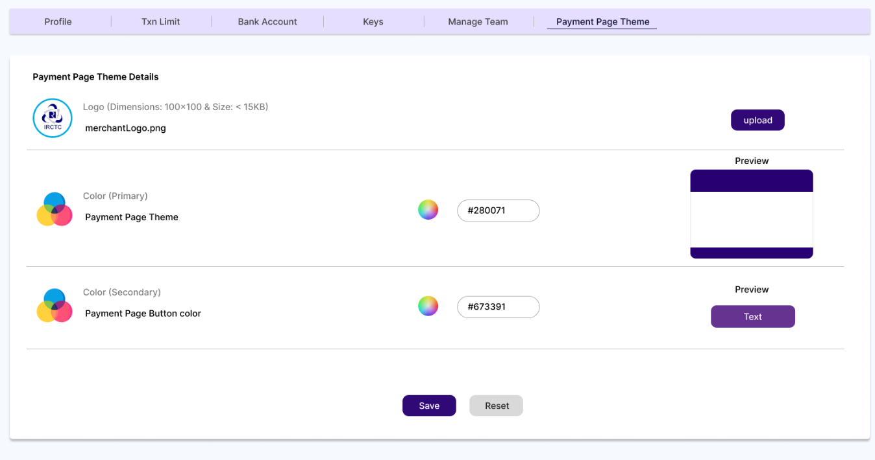

* In this section, user can place request to add/change their logo which is visible across the merchant panel sections and SBIePay payment pages.
* Payment page theme can also be chosen by clicking on primary color picker (for payment theme color) and secondary color picker (for payment page button color), which will open respective color palettes as per screenshot below.

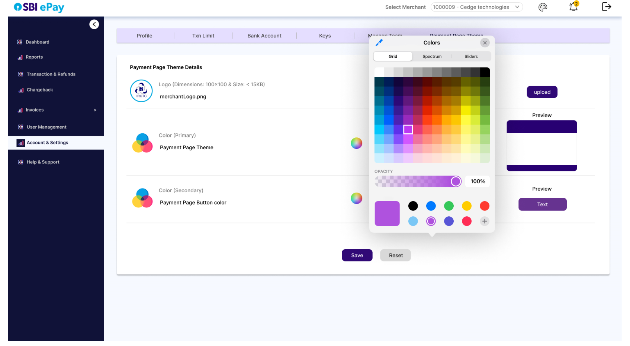

* Clicking on preview will open a preview window which will display the payment page preview with colors chosen as per screenshot below.

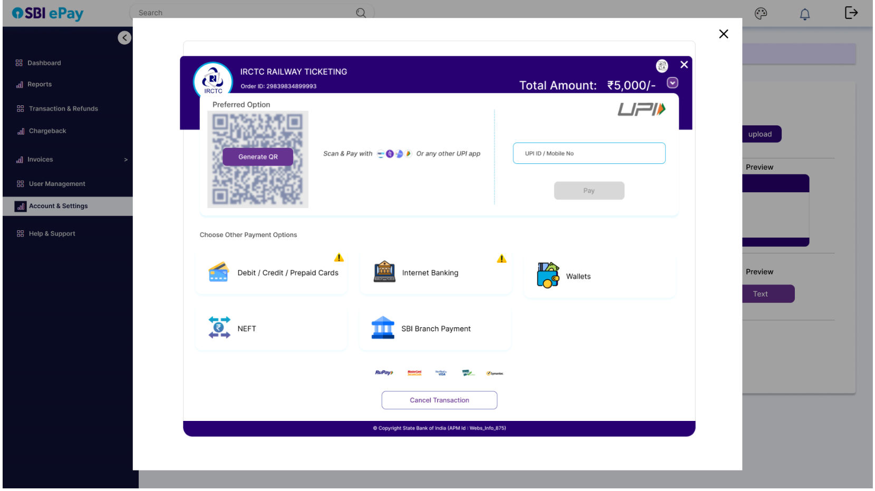

* + 1. Help & Support

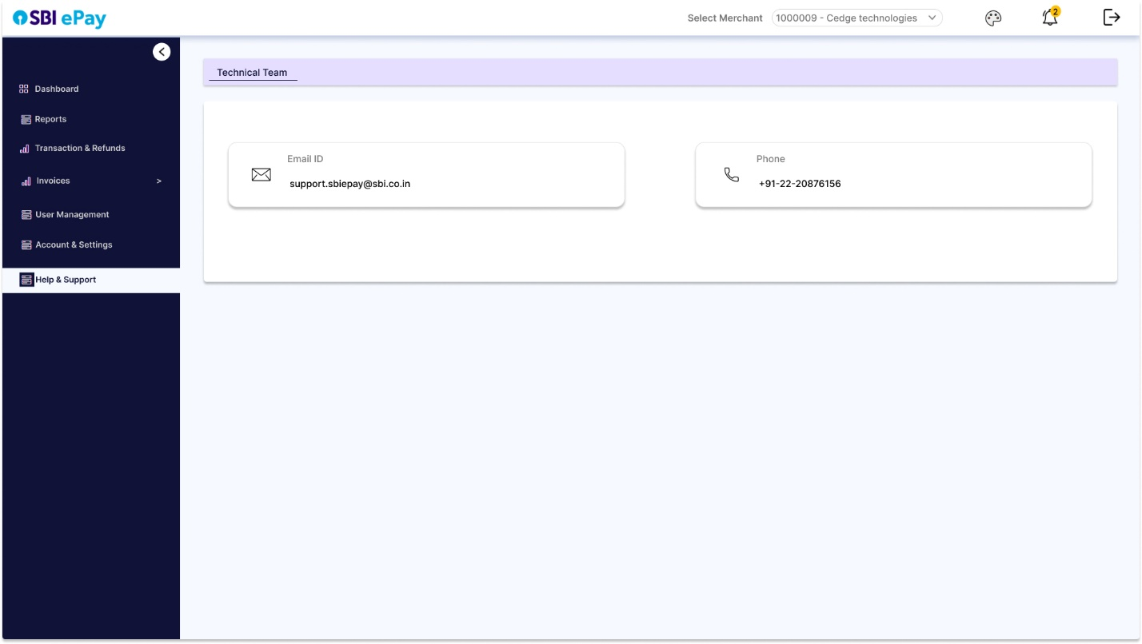

In this option, merchant user will find technical team’s Email ID and phone number to contact in case of issues.

**Note:** Chargeback menu is visible in menu bar in all the screens, however it will not be part of menu bar.

2.4 Footer Bar

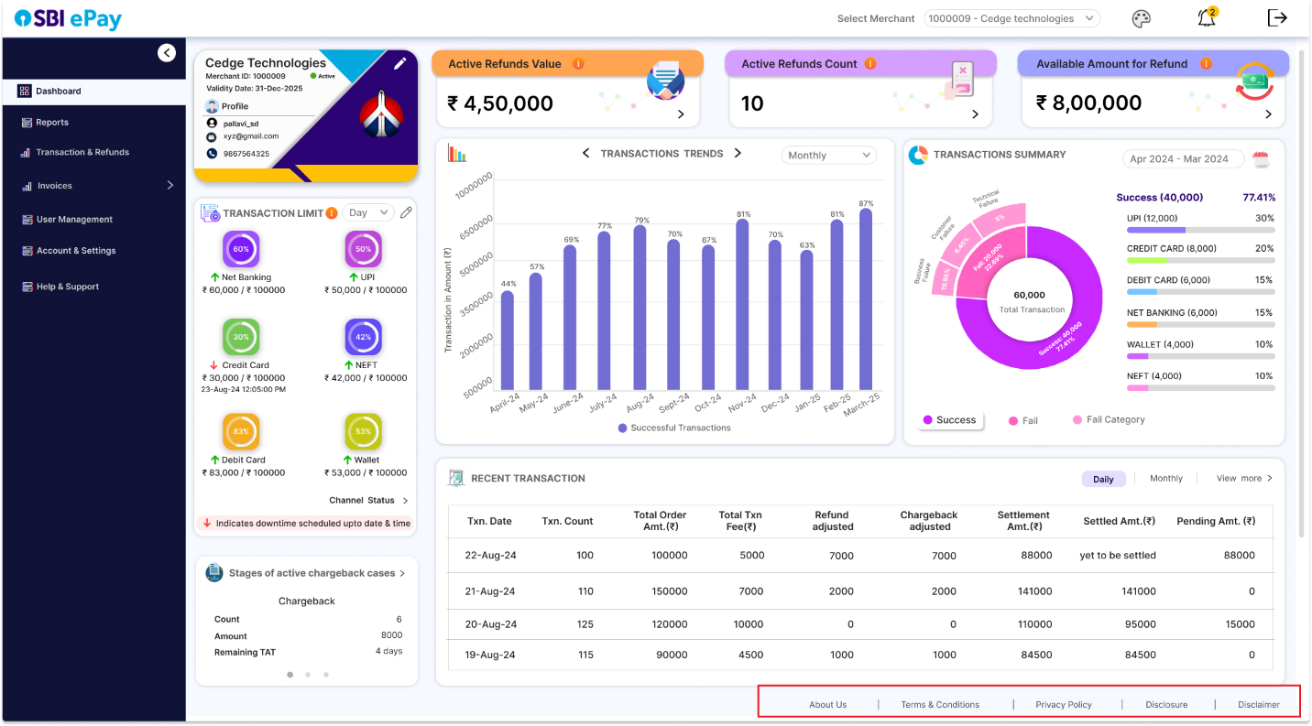

Same as header bar, footer bar will be present at the bottom on all the pages and screens of merchant panel. Clicking on footer bar options such as ‘About Us’, ‘Terms & Conditions’, ‘Privacy Policy’, ‘Disclosure’, ‘Disclaimer’ etc. will display the corresponding text.